UNITEL
Modernisation and internationalisation of Iranian HEIs via collaborative TEL-based curriculum development in engineering and STEM/UNI-TEL

UNITEL project meeting
March 16th 2022

MINUTE

Venue: MEET virtual room

Participants
P1 - USGM, Università degli Studi Guglielmo Marconi, Italy: Ilaria Reggiani, Sara Cella, Renzo Linsalata, Mikail Feituri
P2- UTU, Turun Yliopisto, Finland: Matti Lappalainen
P3 – UaB, Universidade Aberta, Portugal: João Paz
P4 – PRISMA, Prisma Electronics ABEE: Christos Spandonidis, , Emorfili Terzimpasoglou, Areti Petsa, Kostas Sakatis, Zafeiris Tzioridis
P5 – IKIU, Imam Khomeini International University: Amir Zarkeshan
P6 – USB, University of Sistan and Baluchestan: Shahram Mohanna, Mehri Rajaei
P7 – SU, Shiraz University: Ali Akbar Safavi, mehrnoosh Soltanian
P8 – UI, University of Isfahan: Seyed Komail Tayebi, Azam Naghavi
P10 – SCU, Shahid Chamran University of Ahvaz: Gholamhossein Rahimidoost
P12 - NAMVARAN P&T COMPANY: Mani Safamirzaei
P9 – UT, University of Tehran (absent)

March 16th 2022
9.30 – 12.00 CET time (12.00 – 14.30 Iranian Time)

The meeting started at 9.45 CET time there were some technical issues to solve for a UTU keynote speaker of the first session meeting. In order not to delay the meeting‘s start, USGM introduced the Agenda of the meeting and described the rationale of the meeting and the core aims.

USGM decided to start the meeting anticipating the last topic WP7 Financial and administrative issues and remarks. I. Reggiani infirmed the partners about 2 main issues:
- As concerns the equipment (Equipment list validation), USGM sent the comprehensive list (with all the partners’ lists) in 2 previous emails asking for a validation of the items/prices/purposes of use. USGM reminded that the process for purchase of the equipment foresees that
1) First partners will send the validation or updated information to the coordinator, (by the 23rd of March).
2) The coordinator will forward the list to the EU Project Officer for the approval since the list included in the project proposal’s budget has been modified.
3) The coordinator, USGM, if authorized by the Project Officer, will send an email to all the partners that have been authorized to start purchasing the equipment.
To this date (25th March), we miss the validation from UI and UT.
We will ask for the authorization only on behalf of the Universities that have provided the proper detailed information of the Equipment.
- As concerns the tranche of funding, we are contacting CONDOR in order to transfer another tranche of prefunding. Approximately by April 2022, we will schedule the transfer of the II tranche of prefunding, in particular:
- 30% of their total funding to the EU partners (since they have received at the beginning of the project 20% of their total funding)
- 20% of their total funding to the IR partners (since they have received in October 2021 the 30% of their total funding)
According to the IR Partnership Agreement, the Condor’s fee will be in charge of each IR partner (6% of the Payment’s transfer).
We remind you that it is up to the Partners the Financial Planning of the budget. Such II tranche of payments will cover a share of the staff effort and the purchase of the equipment and Travel/cost of stay for a face-to-face meeting to be scheduled in the next months
UTU WP2 introduced the second topic: UNI-TEL Training path development. Topics to face up and comments:
- Update of the e-course’s development and next (virtual) study visits action plan: dates
The first important instructions on how to start designing the lessons of the ecourse have been shared by UTU before the meeting. The Guidelines on how to use OBS and the PPT template have been shared as well and all the documents are available in the WP2 drive folder in the UNITEL main drive folder.
According to the project proposal, 2 study visits will be held online in order to integrate the competencies of the IR partners on distance learning methodologies, pedagogies, etc..
The first study visit according to the doodle preferences will be held on 13rd of April 2022 (on average from 9.30/12.30 cet time).

- Presentation of the draft content of each topic/module (all partners) - Round table overview
Some partners teste the OBS software, there some lacks since it tis a free basic software but USGM ensured that the post production will allow the lessons to assume a professional style and using the same tool will allow the ecourse to benefit from a coherent structure.
Ilaria showed an example of an OBS video lesson realised in TRUST project with a graphic background embedded and a reduction of the external noise.
Akbar asked if possible to change the software, but USGM replied that, at this stage, with 2 months of delays for activities WP2, we could not introduce another software-testing phase, scheduling an external software training and don’t have technical staff responsible for postproduction expert for the new software.
As concerns the MODULE LEADER, it will have the role of coordination of the online lessons’ developments in its module and it will be in charge for the general feedback of the produced material.
It has been approved that the PPT and the recording videos of the ECOURSE Lessons should be in English language with the subtitles in Farsi. USGM will make a check with technicians to detect the best solution.

- Update on Selection of professors (e-course: 15-16 participants per Iranian HEI) and selection of tutors (3 per Iranian HEI).
Each PC HEI partner will be involved in this process. As for the tutors they will be selected from the PC HEIs staff in order to be able to have a thorough knowledge of the course and tools to be used and pass their knowledge to the participants. The last ones will be selected with a public call within each PC HEI based on specific criteria:
- Expertise in the field of engineering and STEM;
- English knowledge level (at least B2);
- ICT skills
The ecourse will be for professors and for instructional designers, the "students" in this case are the professors and instructional designers in partner universities.
The development phase should end in May 2022 and the delivery will be in June and July. It will be online we will organise the delivery in order to have the maximum participation considering the summer holiday issue.

UTU/Matti will send an email to the partners with a recap of the action plan related to WP2: actions, who is in charge and deadlines/tools. The action plan includes the virtual study visits, the webinars, the selection of tutors’ process, etc..
Going on with the agenda, the Engineer Mikail Feituri USGM started the WP2 – ecourse /OBS training session . He followed the Guidelines introducing the practical use of the software and with a demonstration of the OBS settings.
Later on Prisma, Zafeiris introduced an update of the Uni-Tel e-course on Moodle Platform / Task Development of the Virtual learning Environment .
Moodle Platform will be used, Logos and customization needed to be added to Moodle, Need of async e-courses, Need to Define Course Content (Quizzes, Texts , Chapters etc.), Define common licenses, Able to Upload / embed video to Moodle course via link, YouTube, mp4(OBS recording, zoom recording, etc.), Tests at the end of the Course to validate knowledge acquired, FORUM section per course, Remote Labs Moodle compatible, link to external platform
There was a live presentation
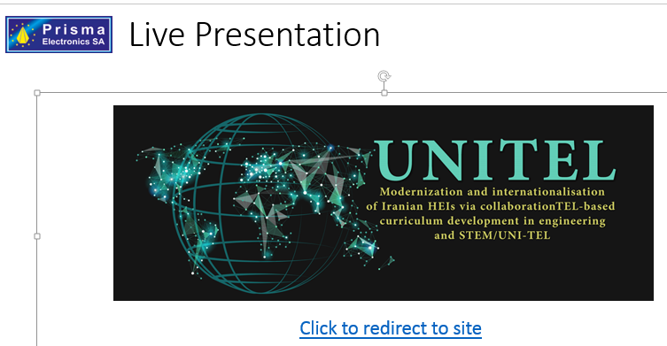

Prisma, Zafeiris highlighted that there are some issues to solve here the topics and then the
- A complete course content layout is needed?
- Is there need for a grading system? Yes we need a grading system to assess the knowledge acquired (it is an indicator for the project impact). It could be an embedded assessment system (i.e. Multiple choice or multiple answers /true false self-assessment at the end of each module).
- User policies, eg. Can students self-enrol?
- Need for badges?
- Courses should be created from teachers or system admin? Admin is strongly recommended, a unique technical coordinator ensure the coherence of the work and the best result.
- Estimated user count to fulfil system requirements
- Which platform for remote labs?
Some answers were provided during the meeting, the detailed information would be discussed together with all the partners and in coordination with the WP leader/Coordinator.
As concerns the WP6 Dissemination and Exploitation, in a later stage SU will introduce the final products and the action plan.
As concerns the WP3 UNI-TEL Training Delivery - WP4 UNI-TEL Curriculum Modernisation, the related activities will be discussed in a later stage.

