UNITEL
Modernisation and internationalisation of Iranian HEIs via collaborative TEL-based curriculum development in engineering and STEM/UNI-TEL

UNITEL Second project meeting
September 28 – 29, 2021

MINUTE

Venue: MEET

Monday, 13 December · 9:30AM – 12:00PM
Google Meet https://meet.google.com/yxg-kmbu-xdi
Video Recoding available in the drive folder of the meeting
https://drive.google.com/drive/folders/1XKACXnLNJYl65i2L-ksty74qlbF8c889?usp=sharing

Participants
Monica Fasciani P1 - USGM, Università degli Studi Guglielmo Marconi, Italy
Matteo Martini P1 - USGM, Università degli Studi Guglielmo Marconi, Italy
Ilaria Reggiani P1 - USGM, Università degli Studi Guglielmo Marconi, Italy
Renzo Linsalata P1 - USGM, Università degli Studi Guglielmo Marconi, Italy
Pasi Malinen P2 – UTU, Turun Yliopisto
Timo Halttunen P2 – UTU, Turun Yliopisto
Matti Lappalainen P2 – UTU, Turun Yliopisto
Heli Brander P2 - UTU, Turun Yliopisto
João Paz P3 - UAb
Christos Giordamlis P4 – PRISMA, Prisma Electronics ABEE
Areti Petsa, P4 – PRISMA, Prisma Electronics ABEE
Kostas Sakatis. P4 – PRISMA, Prisma Electronics ABEE
Amir Zarkeshan P5 – IKIU, Imam Khomeini International University
Shirzad Peik Herfeh P5 – IKIU, Imam Khomeini International University
Rohullah Bayat P5 – IKIU, Imam Khomeini International University
Mohsen Davoudi P5 – IKIU, Imam Khomeini International University
Ahmad Nasseri P6 – USB, University of Sistan and Baluchestan
Shahram Mohanna P6 – USB, University of Sistan and Baluchestan
Mehri Rajayi P6 – USB, University of Sistan and Baluchestan
Leila Sargazi P6 – USB, University of Sistan and Baluchestan
Ali Akbar Safavi P7 – SU, Shiraz University
Dr. Saber Khaghani P7 – SU, Shiraz University
Mehrnoosh Soltanian P7 – SU, Shiraz University
Komail Tayebi P8 – UI, University of Isfahan
Dr Azam Naghavi P8 – UI, University of Isfahan
Dr. Hamidreza Marateb P8 – UI, University of Isfahan
Cyrus Zamani P9 – UT, University of Tehran
Ara Toomanian P9 – UT, University of Tehran
Amir Mohammad Ahadi P10 – SCU, Shahid Chamran University of Ahvaz
Kareem Lowaymi Mutlaq - P10 – SCU, Shahid Chamran University of Ahvaz
Tayebeh Khabir P10 – SCU, Shahid Chamran University of Ahvaz
Yousef Tamsilian P10 – SCU, Shahid Chamran University of Ahvaz
Gholam Hossein Rahimidoost P10 – SCU, Shahid Chamran University of Ahvaz
Parvaneh Tishehzan P10 – SCU, Shahid Chamran University of Ahvaz
Saeed Maghsoudi P12 - NAMVARAN P&T COMPANY
Mani Safamirzaei P12 - NAMVARAN P&T COMPANY
Somayyeh Fallahfard P12 - NAMVARAN P&T COMPANY

Monday December 13rd, 2021
9:30 – 12:00 CET time (12:00 IR time)

The plenary Project Meeting started in time at 9:35 with the Welcome of the Coordinator USGM I.Reggiani and the presentation of the agenda of the day.
She specified that the most important goals of the meeting were:
- identifying the final findings of the research and, in particular, the most relevant information for the next work packages (WP 2 and WP3, WP4);
- identifying the necessary equipment (hardware/software) for the design and development of the online lessons, as well as for the establishment of the remote labs;
- settling the first draft of the content/structure and methodology for the e-course included in the Work package 2 UNITEL Training Path development.

She left the floor to Prof. Gholam Hossein Rahimidoost SCU, leader of WP1 Baseline Analysis, to present the final research findings.
WP1: Baseline Analysis (leader: P10 SCU, Co-leader P2 UTU)
Prof. Gholam Hossein Rahimidoost introduced the final research/s results of the WP1 (see the PPT uploaded in the drive folder WP1: Preparation/Baseline analysis, Task 1.2: Drawing up the state of the Art of HEIs (PC national level), Shahid Chamran University of Ahvaz https://drive.google.com/drive/folders/1XKACXnLNJYl65i2L-ksty74qlbF8c889?usp=sharing ).
The presentation was focused on:
2.1. Policies and guidelines in use for curriculum planning:
2.2. Curriculum planning in practice
3.1. TEL as a practice in your institution
3.2. Technology in use
3.3. Course development process
3.4. Stakeholders involved and their roles and tasks
3.5. Protocol of course assessment
3.6. Identification of TEL /online quality practices or patterns of quality
3.7. Process of continuous improving of educational provision
3.8. Professional development of teachers and instructional designers
4.1. Policy and action plan for industry-relevance
4.2. Infrastructure
4.3. Assessment of learning
4.4. Functionalities of the technical infrastructure
4.5. Use of virtual and remote laboratories
5.1. Staff professionalization
6. Opportunities and challenges for adoption of TEL practices

After the presentation of the WP1 results, M. Fasciani, USGM introduced the new staff member of the Shiraz University, Prof. Ali Akbar Safavi, Ph.D. He introduced himself, its core activities and in particular his multi-years’ experience in e learning environment. He is in fact the Head of the Iranian e-Learning Association (YADA) (https://elearningassociation.ir/).
Furthermore, he presented the opportunity to join the International (IEEE Indexed) Conference to be held on 9-10 March, 2022. The ICeLeT 2022 (The 9th International Conference on e-learning and e- teaching) is hosted by the University of Kurdestan. He would like to organise a specific panel for the project within the event. https://conf.uok.ac.ir/icelet2022/Default.aspx?Lang=En. He asked the partners to check the conference and if they are ready to send papers please let him know. He will keep the partners informed about the panel’s next developments.
As an example of his experience in distance learning, He presented some videos concerning the remote Lab’s practice. As concerns the project, He introduced relevant improvements in the UNITEL dissemination outcomes.
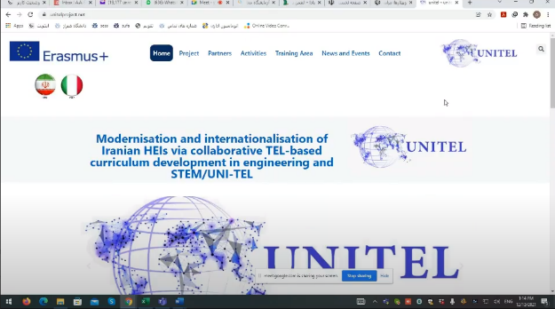
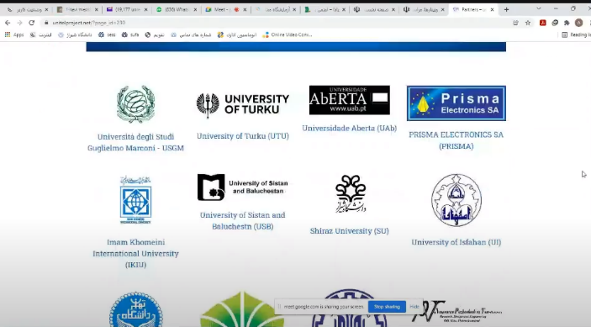

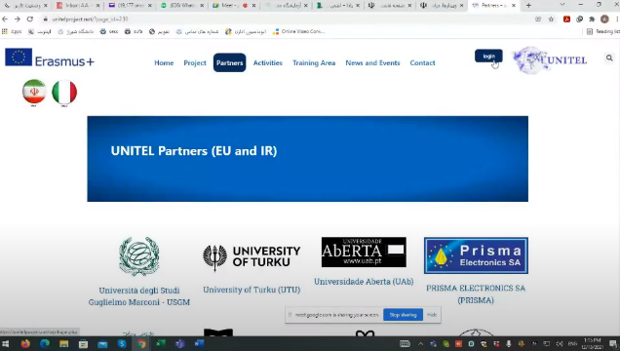
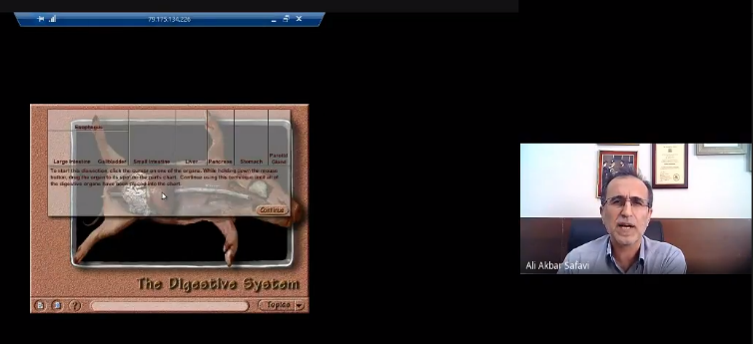
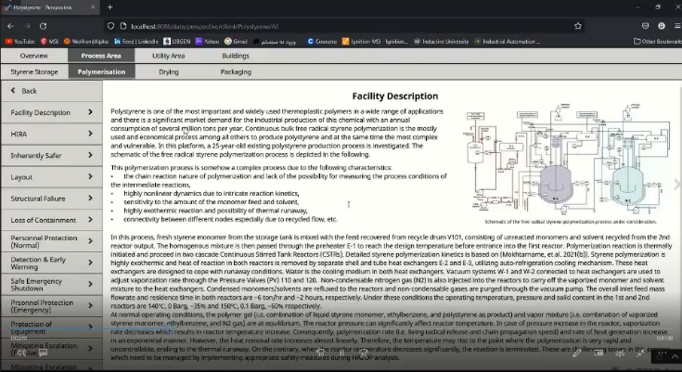
He offered the possibility to the other Iranian partners to join the University’s remote lab. He said that he just need a couple of months to organise the infrastructure and to share the procedure.
It will be a valuable opportunity to reinforce the lab’s practice. It will not replace the project labs’ tasks but it will reinforce the skills and competences of the Iranian academic staff.
He presented the new logo, the revised website and the new dominium. The coordinator and the partners greatly appreciated the significant improvements, the deep experience in e-learning and the remote lab best practice.
Prof. Matteo Martini (USGM) highlighted that is will be important to start from each IR university real lab in order to transform it into a remote lab suitable for the project aims. The settlement of the remote labs depends on the technological infrastructure that the university has. It is essential to share the list of equipment and highlight the compulsory items (Arduino, Raspberry PI, Adobe presenter/OBS, Adalta, etc..) . The choice of the equipment list should comply with the lab’s needs and the distance-learning course’s design and development. We need a common technological infrastructure.

Later on, Timo Halttunen (P2 UTU) presented the deliverable connected to the Activity.1.4 Addendum for Skills and competences of the Universities lecturers in line with the Digital Education Era. (to download the PPT, you can access to the Drive folder https://drive.google.com/drive/folders/1XKACXnLNJYl65i2L-ksty74qlbF8c889?usp=sharing)

Finally, Matti Lappalainen and Heli Brander, (P2 UTU), as leader of WP2: UNI-TEL Training path development, presented a more detailed proposal on e-course modules and next action plan. (to download the PPT, you can access to the Drive folder https://drive.google.com/drive/folders/1XKACXnLNJYl65i2L-ksty74qlbF8c889?usp=sharing)

After the presentation, I.reggiani (USGM) first thanked Matti Lappaleinnen and Heli Brander for the great work, later on, she highlighted that the presented scheduling for the activities was not feasible, in fact, according to the original project workplan the activities of WP3 should be finished by the 14th month (February 2022). We could take some more time but the activities should be finished by April 2022 at latest. Otherwise al the next activities will be delayed.
As concerns the modules, João Paz said that the UAb team has developed a digital assessment framework. He will shared it. It may be useful for the assessment module.
Matti Lappalainen pointed out that one topic could be about 15-30 minutes. E.g. the prof. Safavi´s presentation could be a good example of one way to produce material in a topic. Then just an assignment and it could be ready.
Unfortunately, the discussion delayed the meeting schedule and there was not enough time to discuss about the financial issues. Any financial question or issue will be discussed bilaterally.

The next meeting will be planned on 11th or 12nd of January 2022; the meeting will focused on final reports of the WP1 and the WP2, WP3, Dissemination, Quality and Management issues
A doodle will be sent to define the official date.

The meeting ended at 12.45 CET time.

ID | Action |  | Responsible | Deadline
DEL/ACT | WP1. BASELINE ANALYSIS
1.1 | Comparative analysis (State of the Art of HEIs in Engineering and STEM studies) | SCU and UTU |  | 10/01/2022
1.2 | Guidelines for modernising HEIs engineering and STEM studies curriculum integrating new pedagogical and digital learning approaches | SCU and UTU |  | 10/01/2022
1.3 | Roadmap on industry-relevant Skills and competences | NAMVARAN |  | 10/01/2022
 | WP2 UNITEL training path development
2 | Feedback on the PPT Presented in the Meeting 13/12/2021 – ECOURSE CONTENT |  | All partners | 31/01/2021
 | WP3 UNITEL TRAINING DELIVERY
3 | Send list of equipment with price of each item (with and without VAT), the purpose of use. In the list Arduino, Rasperry PI and Adobe presented should be included. |  | Partners missing | 27/12/2021
 | WP5. QUALITY ASSURANCE
 | Delivery of the Final Quality Plan |  | UAb | 03/01/2022
 | Peer Review Strategy and tool for the WP1 core outcomes’ assessment |  | UAb | 03/01/2022
 | Delivery of the Previous (second) meeting assessment |  | UAb | 03/01/2022
 | Delivery of the Terms Of Reference for the contractualization of the External Evaluator to the coordinator |  | UAb | 03/01/2022
 | Delivery of questionnaire for evaluating the third meeting (13rd December) |  | UAb | 27/12/2021
 | Filling the questionnaire |  | All partners | 03/01/2022
 | WP6. DISSEMINATION AND EXPLOITATION
 | Valorisation plan final version |  | SU | 15/01/2022
 | Structural revision of the UNI-TEL Website and the logo |  | SU | 15/01/2022
 | UNI-TEL Social Accounts (Facebook, Linkedin) |  | SU | 15/01/2022
 | Paper products (brochure) |  | SU | 15/01/2022
 | First newsletter design |  | SU | 27/12/2021
 | WP7. MANAGEMENT
 | Minutes of the third official meeting |  | USGM | 22/12/2021
 | Sending the financial documents |  | Missing partners | 27/12/2021
 | Feedback on financial documents |  | USGM | 10/01/2022

