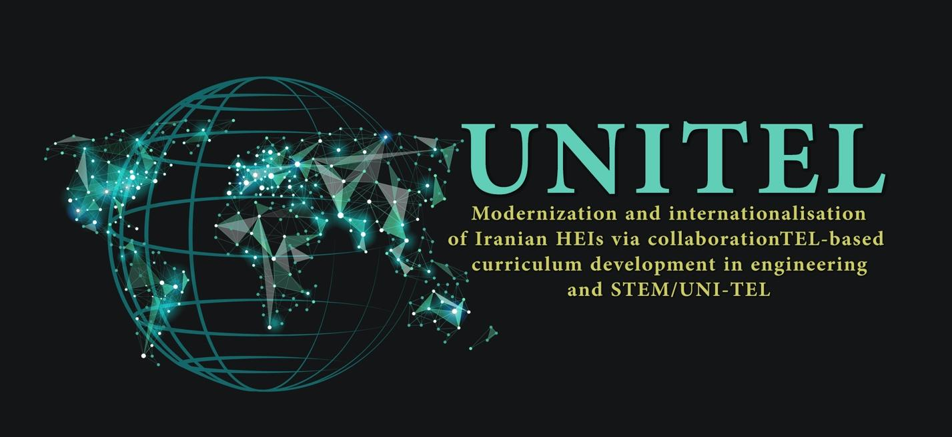

UNITEL E-COURSE

The Development of Learning Materials in a Nutshell

Matti Lappalainen & Heli Brander, P2 – UTU
16th Feb 2022

TABLE OF CONTENTS

1. Introduction 2
2. UNI-TEL e-course 2
2.1. The aims of the UNI-TEL e-course 2
2.2. The participants of the e-course 3
2.3. The structure of the UNI-TEL e-course 3
2.4. Responsibilities in producing the materials 4
3. UNI-TEL e-course development 8
3.1. The materials to be produced for UNI-TEL e-course 8
3.2. Starting the material production process 8

Introduction
These instructions and guidelines are to support the development of UNI-TEL e-course learning material development. In later phases of the project the following themes are discussed and instructed in more detail:

- The technical system to be used for multimedia recordings
- Templates: To produce coherent materials there will be UNI-TEL project templates (including fonts, colours etc.) for
- Powerpoints
- Lecture notes
- Storyboards
- Instructions for cross-evaluation and peer-feedback concerning the topics
- Selection process of the tutors
- Selection of the participants of the e-course
- Exact timetable for the production process

We hope that these instructions will give a good start for your work in institutional material for material production teams!

UNI-TEL e-course

The aims of the UNI-TEL e-course
The overall aim of the UNI-TEL e-course is to empower Engineering and STEM departments at Iranian universities in enhancing skills and competences of professors and instructional designers on innovative collaborative ICT-based practices. These practices are seen as a means to increase curriculum modernisation and internationalisation. The course is motivating the academic staff to acquire key competences and skills crucial for the integration of technology enhanced (TEL) pedagogical approaches in university curricula. It will also promote rational applications of new collaborative teaching and learning ICT-based methodologies. The course is developed together with Iranian and European partners.

General learning objectives of the e-course are:
- To learn the principles of digitalization and enabling technologies that lead to innovative pedagogical practices;
- To learn current trends in pedagogy (industry-relevant, working life oriented pedagogies such as project-based learning and problem-based learning) through the use of pedagogical scripts and instructional scaffolding;
- To learn technologies, protocols and tools for applying ICT in processes and services;
- To be able to implement a project for the digital transformation of a process, area, or department.

The materials of the course will produced in English and then translated in Farsi.

The participants of the e-course
The target group of the e-course are the university professors/lecturers and instructional designers in the Iranian partner universities: at least 91 professors and instructional designers from the universities will register and follow the e-course (15-16 participants/university). In each partner university 70% of the participants will be professors. By the participants and the projects which the participants are elaborating during the e-course, at least 70 courses are modernised by teaching staff till the end of the UNI-TEL project.
The e-course is a good opportunity to clarify the role and functions of the instructional designers in the Iranian universities.

The structure of the UNI-TEL e-course
The course will include different types of elements (figure 1):
- 36 video/audio lessons (from 20 – 60 minutes) to be attended on the platform in asynchronous modality;
- 3 webinar sessions (at beginning, mid-term and end of the e-course) to be attended synchronously by all participants (for the sake of logistical implementation 2/3 groups can be created);
- Project work
- 2 in presence sessions at institutional level (nationally) at the beginning and end of the e-course. The trained tutors will organise, moderate and facilitate the in-presence sessions in their own institution.

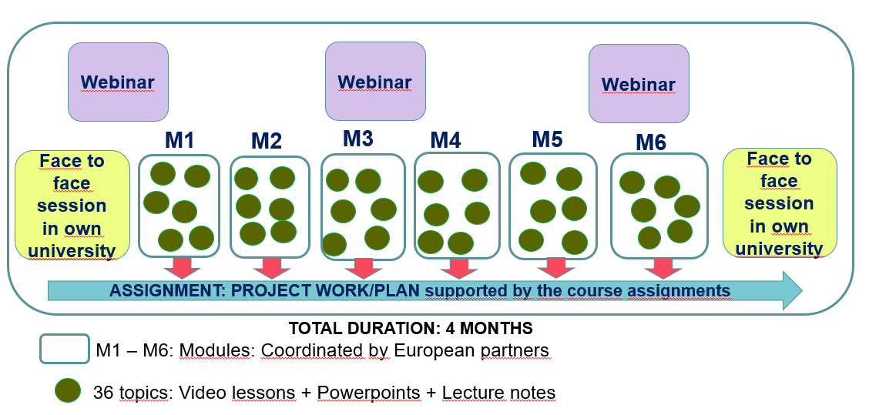

Figure 1. The general structure of the UNI-TEL e-course.

Responsibilities in producing the materials
The roles, responsibilities and responsible partners in the development of the UNI-TEL e-course are presented in table 1.

ROLE | RESPONSIBILITY | PARTNER(S)
Coordination of course development | Coordination of all activities and roles in the different stages of the course development process | P2 UTU
Module coordinators | Coordination and integration of the topics and modules to reach an aligned curricula | UTU: Module 1 and 4  USGM: Module 2 and 5  UAb: Module 3 and 6
Subject experts | Subject experts are producing the learning materials according the guidelines. | All partner universities (1-3/topic)
Cross-evaluators  As a part of the material production cross-evaluation (peer-evaluation) is used. | To give feedback to support the development of other topics. This feedback can include also development ideas, hints and potential references. | All partners involved the course development
Tutors | Organising, moderating and facilitating the course delivery in partner universities (course delivery, the presence sessions) | Each Iranian partner university will select 2 tutors among its own staff.
Learning Management System Support (LMS) | To build up the LMS for the course | P6 PRISMA  Co-leader: P6 USB  All Iranian partner universities
Delivery of the e-course (after the course is ready) |  | P4 PRISMA Leader  P6 USB Co-leader  All Iranian partner universities

Table 1. The roles and responsibilities of partners in course development
The key roles from Iranian perspective in the course development and course delivery are the subject experts and the tutors:
Subject experts. In the team of subject experts it´s important to utilize different expertise: Expertise of content, and the expertise of instructional designers. Instructional designers are supporting teaching staff in their work. This support can be pedagogical support or IT support. In many cases this role is still emerging or part-time in Iranian universities. UNI-TEL e-course is a good possibility to strengthen this role.
Tutors. Each Iranian partner university will select tutors from their staff. The local tutors will organise, moderate and facilitate the course delivery in partner universities. The tutors will participate in online tutor training which is organised before and during the e-course by P2 UTU and P1 USGM. Training will include an overview of the e-course and information and tools that the tutors can use to enhance the training process in their university. If the tutors (or at least another of them) have been taking part in the production of the materials, they are of course already familiar with some content of the course. The selection process of the tutors will be discussed later with all partners.
The modules, the topics and the responsible partners are presented in table 2.
UNITEL e-course modules and topics: Slight modifications in titles still possible after discussions with Module coordinator
MODULE 1: Orientation to the course and modern concepts of learning (Coordinator: P2 - UTU) |  | Responsible partner
M1-1 | Orientation to the course | P2 - UTU
M1-2 | The current state of Iranian higher education - Lessons learnt from the UNITEL Project survey (WP1) | P8 - UI
M1-3 | The concept, models and implementations of e-learning | P10 - SCU
M1-4 | Designing quality e-learning | P9 - UT
M1-5 | Process of e-Learning Design | P9 - UT
M1-6 | Concluding remarks (topic discussed in more detail with the partners of the module) | P10 - SCU
MODULE 2: Student-centered learning in practice and in STEM (Coordinator: P3 - UAb)
M2-1 | How to build learner-centered e-learning | P10 - SCU
M2-2 | Engaging and motivating students with real-world problems in STEM teaching | P5 - IKIU
M2-3 | Student engagement and motivation through voluntary subject choice and flexibility in STEM teaching | P5 - IKIU
M2-4 | Building and utilizing community and collaboration in e-learning | P2 - UTU
M2-5 | Case example(s) of online implementations of STEM | P5 - IKIU
M2-6 | Open educational resources (OER) and MOOCs in online oriented STEM teaching | P3 - UAb

Table 2. The modules, the topics and the responsible partners (continuing in next page)
MODULE 3: Methods and tools of technology enhanced learning (TEL) (Coordinator P1 - USGM)
M3-1 | Building the cornerstones: Teamwork and IT support in universities | P6 - USB
M3-2 | Web applications, tools and programs – examples and practices | P6 - USB
M3-3 | Activating methods and online tools to enrich online learning | P6 - USB
M3-4 | Pedagogical models of e-learning | P9 - UT
M3-5 | Implementing advanced virtual learning (including virtual and remote labs) | P1 -USGM
M3-6 | Best practices of virtual and remote labs | P7 - SU
MODULE 4: Cooperation with the industry and working life relevant skills (Coordinator: P2 - UTU)
M4-1 | Generic skills of STEM experts (21st century skills) | P6 - USB
M4-2 | University-Business collaboration: An overview and some examples | P8 - UI
M4-3 | University’s Technology Transfer (TT) strategies and ecosystems in European and Iranian universities | P2 - UTU
M4-4 | Embedding Enterprise in the Curriculum I: Internships, alumni speakers, company visits etc. | P2 - UTU
M4-5 | Embedding Enterprise in the Curr. II: Joint Masters’ thesis at companies, project assignments etc. | P7 - SU
M4-6 | Cooperation in engineering (The title can be modified) | P7 - SU
MODULE 5: Assessment and feedback as a part of teaching and learning (Coordinator: USGM)
M5-1 | Lessons learnt from the national survey in Iran: Student opinions (WP1) on the role assessment | P10 - SCU
M5-2 | (A framework for digital assessment) including Self-evaluation and peer evaluation | P3 - UAb
M5-3 | Plagiarism detection | P8 - UI
M5-4 | Learning analytics | P1 -USGM
M5-5 | Electronic exams | P1 -USGM
M5-6 | Automatization of feedback | P1 -USGM
MODULE 6: Modernization of teaching (Coordinator: P3 - UAb)
M6-1 | Strategies and policies supporting development | P5 - IKIU
M6-2 | Quality assurance (QA) standards of e-learning | P3 - UAb
M6-3 | Degree evaluation | P3 - UAb
M6-4 | How to utilize feedback as a source of development | P8 - UI
M6-5 | Curriculum development | P7 - SU
M6-6 | Staff development as a tool for development | P9 - UT
 | LEARNING MANAGEMENT SYSTEM (LMS) (ALL MODULES) | P4 - PRISMA
 | PROJECT WORK ELABORATION (ALL MODULES) | P2 - UTU

Table 2. The modules, the topics and the responsible partners.

The preliminary content of the topics is presented in Annex 1.
The names of the responsible subject experts should be filled in the table in GoogleDrive till Wed 15th February 2022. The list should be updated, in needed later:
https://docs.google.com/spreadsheets/d/1BjWvuUF6hYrM9dXcp13A6rNGQkFAICPr/edit?usp=sharing&ouid=103106027257106377880&rtpof=true&sd=true

UNI-TEL e-course development

The materials to be produced for UNI-TEL e-course
The materials to be produced by the partners for the topics (“lectures”) are:
- Powerpoint (PPT) presentations (slides). 10 – 15 slides.
- Lecture notes. “Powerpoints in speech”. Textual documents presenting the topic in-depth and providing different hypothesis, opinions theories and etc. as well as list of additional readings and resources. 15 – 20 pages.
- Video/multimedia lectures. Combining different presentation and powerpoints, 20-60 minutes (e.g. 2 x 30 minutes).
- In addition. The experts (= “course teams”) producing the topics are encouraged to utilize their experience and innovation to use other elements in their lectures , such as:
  - Quizzies
  - Electric whiteboard
  - Free simulators
  - Online math tools
- Input to project work/plan assignment. The learning experiences during topics and modules are integrated in a project work elaborated by all participants of the course. The course leader P2 – UTU will cooperate with subject experts to split the project work in pieces by the modules/topics.

Starting the material production process
Each topic will have:
Learning objectives of the topic
- What a participant knows and can do after studied the topic

Content of the topic
- The main content of the topic

Evaluation methods and criteria
- The learning experiences during topics and modules in UNI-TEL e-course are integrated in a project work elaborated by all participants of the course. The course leader P2 – UTU will cooperate with subject experts to split the project work in pieces by the modules/topics.
- In addition to that the institutional subject expert team can discuss are some other assessment methods used and what are criteria for successful finishing of the topic?

Please fill Annex 2 to start the process: Deadline 7th March 2022
Annex 2 includes a template to produce the first draft syllabus of UNI-TEL e-course. As a part of the template it´s also possible to rise questions concerning the material production process.
Please fill the Annex 2 with your subject expert team and upload it in UNI-TEL GoogleDrive by 7th March 2022 under the respective module (module 1-6) under WP2.
https://drive.google.com/drive/u/1/folders/1Hgmec15bL0vKGilI2y01SJioH0ysq77b

ANNEX 1 The modules, the topics, responsible partners and the preliminary content of the topics
UNITEL e-course modules and topics: Slight modifications in titles still possible after discussions with Module coordinator |  | Partner | Preliminary content (Partner meeting 12th January 2022)
MODULE 1: Orientation to the course and modern concepts of learning (Coordinator: P2 - UTU)
M1-1 | Orientation to the course | P2 – UTU | - Course’s aims and objectives  - Structure and contents of studying  - Methods of studying  - Role and requirements of participants  - Guidance and support provided
M1-2 | The current state of Iranian higher education - Lessons learnt from the UNITEL Project survey (WP1) | P8 – UI | - Contents are based on the WP1 report: e.g. Addendum for Skills and competences of the Universities’ lecturers in line with the digital education era
M1-3 | The concept, models and implementations of e-learning | P10 – SCU | - History and diversity of the concept of e-learning  - Alternative ways to utilize network as part of the learning environment  - Examples of alternative well-working implementations of e-learning
M1-4 | Designing quality e-learning | P9 – UT | - Perspectives on quality e-learning (according to research)  - Basic principles for designing quality learning (learning is not knowledge transfer but rather based on the student’s activity)  - Changing role of a teacher into instructor (who organizes and moderates activities in a learning environment, develops community culture and supports students’ path to facilitate learning)  - Aspects needed in quality e-learning design: content expertise, target group knowledge, pedagogical expertise, technical expertise  - Usability of the e-learning environment  - Features of a quality e-learning environment

M1-5 | Process of e-Learning Design | P9 – UT | - The steps for planning an online course and writing an online course script
M1-6 | Concluding remarks (topic discussed in more detail with the partners of the module) | P10 – SCU | - Topic discussed in more detail with the partners of the module

MODULE 2: Student-centered learning in practice and in STEM (Coordinator: P3 - UAb) |  | Partner | Preliminary content (Partner meeting 12th January 2022)
M2-1 | How to build learner-centered e-learning | P10 – SCU | - The main principles, means and methods of learner-centeredness and how to adapt this information in e-learning design
M2-2 | Engaging and motivating students with real-world problems in STEM teaching | P5 – IKIU | - Based on creating a student’s understanding of the applicability, necessity, and relevance of STEM knowledge
M2-3 | Student engagement and motivation through voluntary subject choice and flexibility in STEM teaching | P5 – IKIU | - Based on strengthening the student's motivation through arising personal interest and flexible teaching arrangements
M2-4 | Building and utilizing community and collaboration in e-learning | P2 - UTU | - Based on arising the student’s social motivation and reinforcing learning through interaction
M2-5 | Case example(s) of online implementations of STEM | P5 – IKIU | - Introducing interesting practices in STEM-related e-learning
M2-6 | Open educational resources (OER) and MOOCs in online oriented STEM teaching | P3 – UAb | - Introducing interesting STEM-related open educational resourses (OER)

MODULE 3: Methods and tools of technology enhanced learning (TEL) (Coordinator P1 - USGM) |  | Partner | Preliminary content (Partner meeting 12th January 2022)
M3-1 | Building the cornerstones: Teamwork and IT support in universities | P6 – USB | - Perspectives and key issues for building an institutional e-learning team to ensure quality implementations
M3-2 | Web applications, tools and programs – examples and practices | P6 - USB | - Introduction of selected web applications, tools and programs (and resources where to find more)
M3-3 | Activating methods and online tools to enrich online learning | P6 - USB | - Introduction of selected activating methods and online tools (and resources where to find more)
M3-4 | Pedagogical models of e-learning | P9 – UT | - Introducing different pedagogical models such as exploratory learning, project learning, problem-based learning, community learning, phenomenon-based learning
M3-5 | Implementing advanced virtual learning (including virtual and remote labs) | P1 -USGM | - Implementing virtual labs, remote labs, simulations, educational games etc.
M3-6 | Best practices of virtual and remote labs | P7 - SU | - Selected good TEL practices to inspire and arise students’ own thinking

MODULE 4: Cooperation with the industry and working life relevant skills (Coordinator: P2 - UTU) |  | Partner |  | Preliminary content (Partner meeting 12th January 2022)
M4-1 | Generic skills of STEM experts (21st century skills) | P6 – USB |  | - Generic (or transferable) skills and supporting their development in university studies  - WP1 / Addendum for Skills and competences of the Universities’ lecturers in line with the digital education era
M4-2 | University-Business collaboration: An overview and some examples | P8 – UI |  | - Examples from Iran and Europe (utilizing WP1)
M4-3 | University’s Technology Transfer (TT) strategies and ecosystems in European and Iranian universities | P2 – UTU |  | - Get to know and learn from cases from Iran and Europe
M4-4 | Embedding Enterprise in the Curriculum I: Internships, alumni speakers, company visits etc. | P2 - UTU |  | - In topics 4.4. and 4.5 different forms of “student oriented” ways to support industry relevant skills are presented
M4-5 | Embedding Enterprise in the Curr. II: Joint Masters’ thesis at companies, project assignments etc. | P7 – SU |  | - In topics 4.4. and 4.5 different forms of “student oriented” ways to support industry relevant skills are presented
M4-6 | Cooperation in engineering (The title can be modified) | P7 – SU |  | - Input e.g.from WP1
MODULE 5: Assessment and feedback as a part of teaching and learning (Coordinator: USGM) |  |  | Partner |  | Preliminary content (Partner meeting 12th January 2022)
M5-1 | Lessons learnt from the national survey in Iran: Student opinions (WP1) on the role assessment |  | P10 – SCU |  | - Survey results (WP1)
M5-2 | A framework for digital assessment including Self-evaluation and peer evaluation |  | P3 - UAb |  | - Different ways to utilize self-evaluation and peer-evaluation as a part of learning
M5-3 | Plagiarism detection |  | P8 - UI |  | - Ways to avoid cheating in virtual learning
M5-4 | Learning analytics |  | P1 -USGM |  | - The concept of learning analytics and different tools for that to follow up and support learning
M5-5 | Electronic exams |  | P1 -USGM |  | - Electronic exams as a way for flexible and reliable assessment for learning
M5-6 | Automatization of feedback |  | P1 -USGM |  | - Finding cost-effective ways to support learning

MODULE 6: Modernization of teaching (Coordinator: P3 - UAb) |  | Partner | Preliminary content (Partner meeting 12th January 2022)
M6-1 | Strategies and policies supporting development | P5 – IKIU | - Getting to know the university level strategies and policies from Iran and EU
M6-2 | Quality assurance (QA) standards of e-learning | P3 – UAb | - Getting to know different standards of e-learning
M6-3 | Degree evaluation | P3 – UAb | - How universities are evaluating the learning results of students and how students are evaluating teaching on degree level?
M6-4 | How to utilize feedback as a source of development | P8 – UI | - How the results of different evaluations are utilized by the teachers, departements and by the university
M6-5 | Curriculum development | P7 – SU | - The strategies and methods for curriculum development  - Utilizing the results of WP1
M6-6 | Staff development as a tool for development | P9 – UT | - Staff development in the strategies and policy documents  - Different ways of staff development: training, mentoring, self-study, peer-learning
 | LEARNING MANAGEMENT SYSTEM (LMS) (ALL MODULES) | P4 - PRISMA
 | PROJECT WORK ELABORATION (ALL MODULES) | P2 -TU

ANNEX 2
UNI-TEL e-course: Draft syllabus and questions concerning the material production process
Code of the topic M_ - _ | Name of the topic
Names of subject experts |  | Email
First name | Surname
Learning objectives
- Objective 1:
- Objective 2:
- Objective 3:
- …
- Objective N:
Content of the topic:
- the main content of the topic (4-6 themes)

Evaluation methods and criteria
- The learning experiences during topics and modules in UNI-TEL e-course are integrated in a project work elaborated by all participants of the course. The course leader P2 – UTU will cooperate with subject experts to split the project work in pieces by the modules/topics.
- In addition to that the institutional subject expert team can discuss are some other assessment methods used and what are criteria for successful finishing of the topic?
Questions at this point of the process?
Note: add the names of subject experts also in GoogleDrive:
https://drive.google.com/drive/u/1/folders/1Hgmec15bL0vKGilI2y01SJioH0ysq77b

