

UNITEL E-COURSE

OBS Studio

Short Guideline

|  |  |
| --- | --- |
| DELIVERABLE DESCRIPTION | |
| Deliverable number and name | OBS Studio - short guideline |
| Due date | Month N 14 |
| Work Package | WP2 |
| Author | Mikail Feituri (USGM) |
| Reviewers | / |
| Language | English |
| Approved by | All partners |
| Version | N. 1 |

**Document history**

|  |  |  |
| --- | --- | --- |
| Issue date | Version | Comments |
| 14/02/2022 | 1 | Updated google Drive folder and contact email |
|  | 2 |  |

**Disclaimer**

This document contains the description of the UNI-TEL project work and products. Certain parts of it might be under partners’ Intellectual Property Right (IPR) rules therefore, prior to its use please contact the consortium leader for approval.

In case you believe that this document harms in any way IPR held by you as a person or as a representative of an entity, please do notify us immediately.

The authors of this document have taken any available measure in order for its content to be accurate, consistent and lawful. However, neither the project consortium as a whole nor the individual partners that implicitly or explicitly participated in the creation and publication of this document hold any sort of responsibility that might occur as a result of using its content.

Table of Contents

1. Initial settings 5

2. Use of the OBS software 8

3. Recordings 11

4. Delivery 11

5. Steps for the video lesson recording 12

6. Contacts 12

7. Annex I: Power Point template for video lessons 12

Abstract

OBS Studio is a free and open-source software suite for recording and live streaming. The document aims to guide UNI-TEL lecturers in recording video lessons by using OBS studio.

# Initial settings

Teachers’ guide – Università degli Studi Guglielmo Marconi

* Download the programme from <https://obsproject.com/> by selecting the button for the operating system you are using.
* 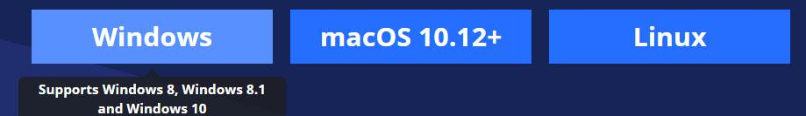
* Install OBS following the instructions.
* At start-up you will be asked to run the Auto-configuration wizard, choose yes and select:
  1. Optimize just for recording, I will not be streaming, click Next

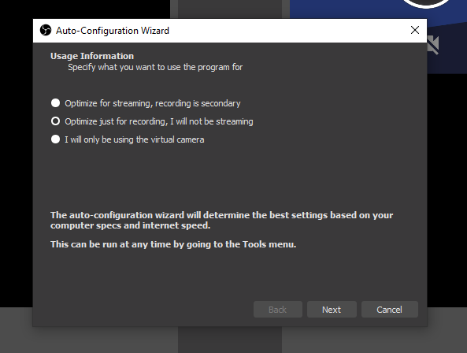

* 1. Base (Canvas) Resolution: **1920x1080** 1
  2. FPS, leave unchanged, it should be changed in another menu later on. click Next

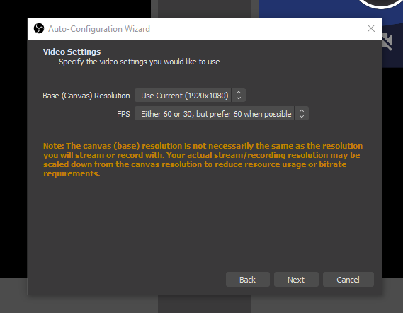

* 1. Complete the Auto-configuration wizard by clicking on Apply Settings
* 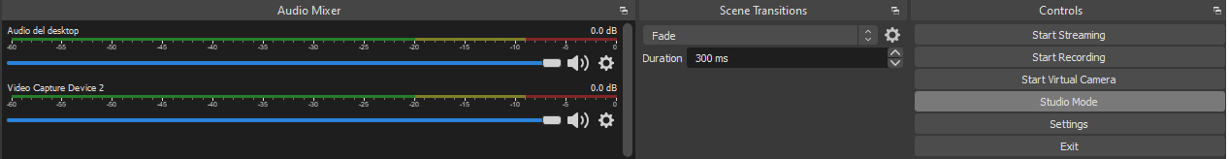Go to Settings
* Change settings as follows: 2
  1. **Output -> Streaming**
     + Video Bitrate: **2500 Kbps**
     + Encoder: Software (x264)
     + Audio Bitrate: **192**

1. **Output -> Recording**
   * Recording quality: **Same as stream**
   * Recording Format: **mp4**

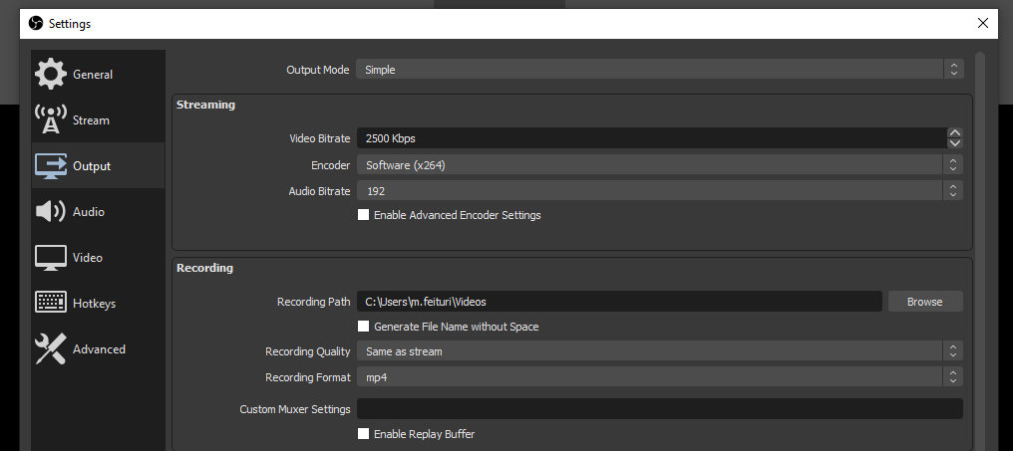

* 1. **Audio -> General**
     + Sample rate: **48Khz**

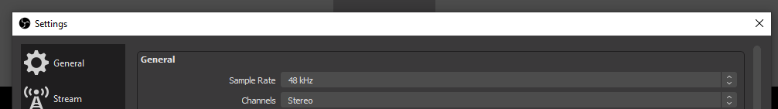

* **Video**
  + - Base (Canvas) Resolution: as much as possible1
    - Output (Scaled) Resolution: same as Base Resolution
    - Common FPS Values: **25 PAL**

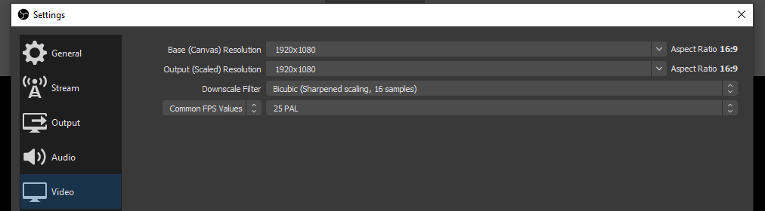

* Click On Apply, and then OK.
* Reboot the software to allow it to load all settings at start-up.

__________________

1. The available resolutions depend on the monitor resolution; if 1920x1080 is not provided then choose the highest one available.
2. The following settings are only those that differ from the software defaults.

# Power Point settings

If PowerPoint is not used skip to the next step (pay attention to notes 3 and 4)

* Open the PowerPoint lesson and maximise the software
* Select the ‘Slide Show’ tab and then click the ‘Set Up Slide Show’ icon
* Choose ‘Browsed by an individual (window)’
* Click OK and start the presentation

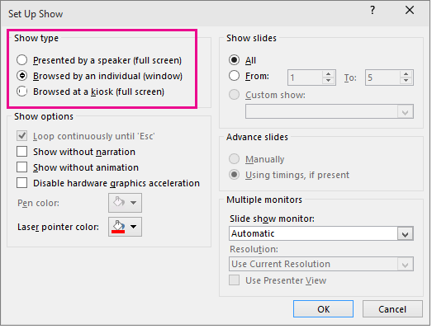

# Use of the OBS software

* Click on + in the tab Sources

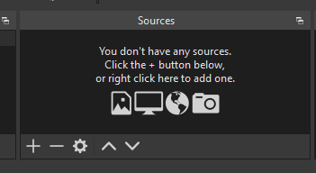

* Choose “Window capture” 3

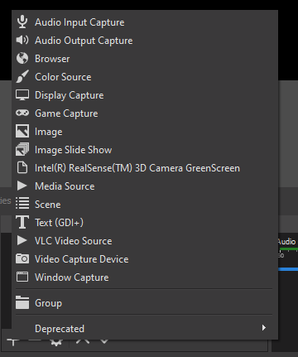

* Click OK
* Choose Window: [POWERPNT.EXE]: File name…4

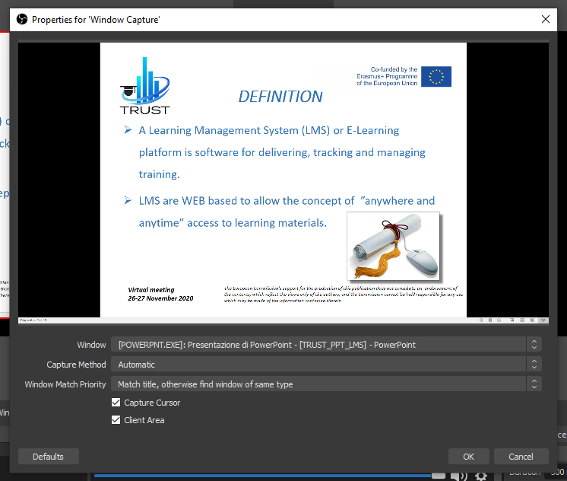

* Click OK

1. In case you need to capture other software or content in full screen you can use the source "Capture the screen" but we encountered problems in some computers (nothing was captured or it became tricky in devices with only one monitor).
2. If you use a presentation software other than PowerPoint, you should find it in the list (you can try).

* You need to shrink the PowerPoint window in OBS to make room for teacher's webcam (by dragging the red corner at the top left of the video source you have just inserted).
* The PowerPoint slide should take up about two thirds of the preview area:

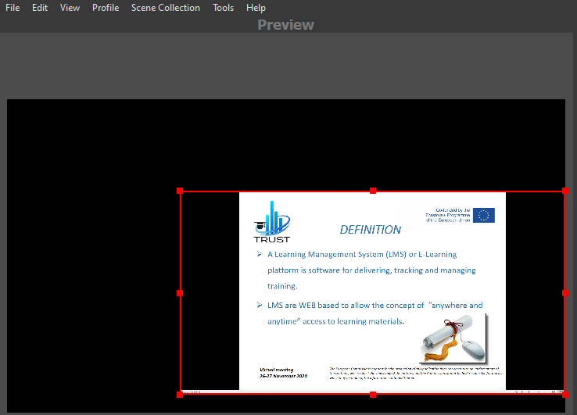

* Click again on + in the Sources tab
* Choose “Video Capture Device”
* Select:
  1. Create new “Video Capture Device”
* Click OK
* It should show the webcam preview 5
* Click OK
* The webcam will be located by the software in the top left-hand corner. 6
* You must ensure that the two video sources do not overlap and are not outside the capture area. If not, place them as in the example below.



1. If the preview is not displayed, try choosing a different Device in Properties for ‘Video Capture Device’
2. It is recommended to stand in such a way that the light sources are in front of and not behind you.
3. If you want to remove a source added by mistake, select the source and click on the - button next to the + button.
4. With regard to audio settings, everything should already be configured.

# Recordings

1. Formal dress is required;
2. A neutral background behind the teacher is required;
3. The teacher's face and the room where the lesson is recorded must be well illuminated;
4. Before recording the whole lecture, it is necessary to send a short test to the Marconi multimedia department. This step is essential to ensure that the video complies with audio-visual standards and that it is compatible with any further processing;
5. If the video sent to the multimedia department does not meet the required standards, the recording has to be repeated;
6. Click on "Start Recording" to record the lesson;
7. The PowerPoint presentation must be handled directly by PowerPoint, the recording preview in the OBS software is not interactive. You can minimise OBS and it will continue recording;
8. "Stop recording" in OBS allows you to save the video file.

# Delivery

1. Recorded files must be shared on a dedicated Google Drive folder of the N. MODULE <https://drive.google.com/drive/folders/1Hgmec15bL0vKGilI2y01SJioH0ysq77b?usp=sharing>
2. The editor will insert the cover and finalise the video lesson;
3. The video will be edited by the multimedia department at USGM according to the graphics agreed for the UNI-TEL project.

# Steps for the video lesson recording

FIRST PHASE

1. Download OBS following this guide instruction
2. 1/2 minutes of trial recording to evaluate framing - audio - file suitability
3. Upload the trial lesson on Google Drive dedicated folder before the online training session
4. Online training session with Mikail Feituri

SECOND PHASE

1. realization of a 16: 9 ppt presentation according to the template provided (annex of this guideline)
2. sending the PPT presentation for evaluation and any corrections to [i.reggiani@unimarconi.it](mailto:i.reggiani@unimarconi.it) / [s.cella@unimarconi.it](mailto:s.cella@unimarconi.it)
3. AFTER HAVING THE OK of the slides and try
4. recording of the first lesson from 45 to 60 minutes
5. Upload the lesson on Google Drive dedicated folder of the N. MODULE (WP2) <https://drive.google.com/drive/folders/1Hgmec15bL0vKGilI2y01SJioH0ysq77b?usp=sharing>

(In case, further detail on the master contents developing, learning objects storage and naming will be provided separately)

# Contacts

Mikail Feituri: [m.feituri@unimarconi.it](mailto:m.feituri@unimarconi.it)

# Annex I: Power Point template for video lessons