Modernization and Internationalisation of Iranian HEIs via collaborative TEL-based curriculum development in engineering and STEM

State of the Art of HE for TEL

Institutional and National Report
Imam Khomeini International University (IKIU)

Chapter 1. Institution Information

- Name of the partner
Imam Khomeini International University- defined in UNI-TEL as P5
- Names of respondents, positions, departments
Rohullah Bayat,University.PhD, Vice Chancellor in International Affairs; Amir Zarkeshan .Ma, Assistant manager in International and Scientific Cooperation, experienced in university curriculum Designing.
- Provide a short introduction describing the methodology you used and the number and types of sources
Enhanced learning in IKIU has been done in different methods with regard to the conditions and receivers of the service, the university started to use of E-learning method in 2016 and at first the related department were covering the only in university students, we used e- learning methods as an new approach beside our traditional classroom methods (in person classes)
In 2016 to 2019 the Virtual Learning department capacity were over 700 for only undergraduate students through online learning method.
Upon Corona Virus outbreak in Iran in February 2020, the University had to keep alive its educational affairs based on E- learning in which over 10000 students and professors at diverse fields and levels could have online connection through LMS.
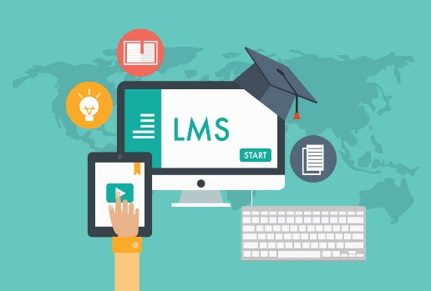
The blended learning is also used in some of IKIU programs (mostly laboratories), also regarding to the low number of PhD students, their classes perform in person.
- Please keep your answer short, maximum 1 page

Chapter 2. Existing practices for curriculum planning

- Name of the partner,
Imam Khomeini International University- defined in UNI-TEL as P5
- Names of respondents, positions, departments.

Abbas Kaviani.PhD, Deputy in Educational Affairs; Siavash Gholizade, Assistant manager in Educational Affairs. Ma; Leyla Fashalang.PhD, Instructor in curriculum Designing, Amir Zarkeshan .Ma, Assistant manager in international cooperation,
- Provide a short introduction describing the methodology you used and the number and types of sources
Main source of curricula for Iranian Universities are the Iran Ministry of Science where has a different specific commissions in diverse field of studies in which based on the country's needs different subjects of studies investigate and get the confirmations and finally send to the Universities to being implemented (every university where has license for the study program can implement the confirmed curriculum on it).
Second source for the curricula designing or modifying are the Universities themselves, in which the curriculum being designed or modified based on the regional or provincial needs which can be collected regarding to regional needs and conditions based on the region where the university located.
Curriculum designing in IKIU benefiting from both ways (ministry and university), second method in IKIU is doing upon the university's scientific department demands in which the new course syllabus initially being prepared and designed, the designing curriculum will investigate by the commission of University high relevance expertise and if approved it would be sent to the Iran ministry of science for the ultimate confirmation.
The main pattern for the curriculum designing has been prepared by the Ministry of Science in which the framework are defined and clarified for different level and field of study, in this pattern numbers of credit and performing class hour are defined in different field and levels, for instance unit numbers for undergraduate are 132-140, post graduate are 28-32 and for doctoral students concluded of 36.
Virtual learning department founded in 2016 in IKIU which also included the blended learning method but after outbreak of covd-19 to alive the university activities, all the courses had to being implemented virtually and online.
University Activities continue during the Pandemic
- Entire of university’s classes at diverse fields and levels have been performing online.
- Laboratory classes have been performing online as far as possible, for the undergraduate the recorded lab works perform to the students and for the Ma and PhD students performances are blended, online and in person (regarding to the numbers of students), simulations are also the technic which have been used in Labs.
- Departments’ Meeting keep working online
- All the meetings relating to different part of university have been held online
- All Scientific Seminars have been done online
- Brain Storming in the health care portion and Future studies have been done online
- Courses in the field of sports and psychological immunity have been done online
- All the Workshops as far as possible have been done Online
- All International academic Webinars have been done online
- Please keep your answer short, maximum 1-1 ½ page per question

2.1. Policies and guidelines in use for curriculum planning
- How do you plan the initiation of a course (e.g. needs analysis for demand and constraint identification etc)
Producing the curricula regarding to the date knowledges and society needs, national needs, provincial needs and city need.
Arranging appropriate educational and curriculum programs to create the necessary skills and capabilities for graduates to enter the labor market
Organizing curricula in a way that strengthens the research spirit in students
Fit the curriculum designing with the University facility and capability

- What kind of goals are set in the organizational strategy and other governing documents for overall curriculum planning and development?
The Board of Trustees of Imam Khomeini International University, in its 17th meeting on 1392/12/15, has defined the development of a strategic document of the university in the form of a strategic document in the horizon of 1404, as one of the main missions of the new management of the university.
Imam Khomeini International University (IKIU) in order to be international and accelerate the scientific cycle of the country and the dynamism and fruitfulness of scientific and cultural activities, developed a 5 years or 10 years comprehensive strategic plan, for now we are on this Comprehensive strategic plan until the year1404, which is the result of years of research, consensus and The participation of the academic body of the university which is accompanied by a vision to achieve horizons of progress and development in the coming years. Strategic planning and development of plans will help our operational policies in the flourishing of the university in various fields of science, research, education, culture, society, entrepreneurship, etc. The strategic plan of the university in the horizon of 1404 has been compiled in line with the slogan and mission of the university based on the statute approved by the Supreme Council of the Cultural Revolution. The general situation of the university in each of the faculties in terms of the number of faculty members, number of students, number of courses and the levels by the year are finalized and detailed until the year 1404.
- Are the needs of working life and the industry somehow described in the governing documents? If they are, please describe, how?
Imam Khomeini International University is located in Qazvin province where is one of the 31 provinces of Iran and is located in the northwestern part of the country. This province, with only 1% of the country's area, has a role of nearly 8% in Iran's economy and products. The area of this province is about 15.820 square kilometers and it is neighboring with Mazandaran, Gilan, Hamedan, Zanjan, Markazi and Alborz provinces. Giving more explanation, Gazvin is one the city where is surrounded by three industrial cities with many different factory in it also Qazvin has rich agricultural and horticultural talents, which with 4899 thousand hectares of agricultural lands, is able to produce about 4 million tons of agricultural, horticultural and livestock products annually. In terms of geographical location crossing point in the country and proximity to Tehran province, it has suitable conditions for investment and marketing in various agricultural sectors. Qazvin plain in terms of historical background and agricultural products, has a very important economic and historical importance among the plains of Iran and is one of the nine most important agricultural hubs in the country. In coal production, hazelnut ranks second, edible mushroom ranks third, edible mushrooms rank second, grapes rank second, olives rank second, cherries rank second, grain corn ranks seventh, fodder corn ranks second and nectarine ranks third among the country's provinces. Is. For this reason, this region is the first plain in Iran to have an independent budget line in the country.
Also Qazvin province due to being located in the communication bottleneck of the northern and western provinces of the country, proximity to Tehran, having several industrial cities (Alborz Industrial City, Caspian Industrial City And Lia Industrial City ) has a very privileged position to invest in various fields. This province is ranked first in Iran and third in the world in terms of tourist location and number of historical monuments. It is worth mentioning that Qazvin has been introduced as the calligraphy capital of Iran. This province has always been one of the centers of calligraphy in the country and even in the world has been raised.

All of these aforementioned reasons forced all the universities in the province to move on the province's regional needs in different aspects, job satisfaction, people need, industry need, agriculture need, cultural need etc.
In IKIU the Process of create a new curriculum start from the comity in IKIU scientific departments, the department suggested curriculum (mostly regarding to the needs) being investigate in the university's specific commissions (there are divers commissions in different field of studies) and if the new syllabus approved it would be send to the Iran higher education Ministry for the final approval, the new curriculum would be implemented if got the ministry approval.
- Is TEL/online learning part of the overall strategy for your institution’s development and how?
Yes it was. Online learning has a long history in IKIU as a state international university, some of the reasons for online learning in IKIU back to the university policy regarding to the society more demand, country or regional needs (by this kind of service, the expenses descend for both side university and students), other reason were regarding to the international dimension of IKIU that can have students globally from every country around the world, that many of our applicants prefer to get the service virtually.
- Do you foresee laboratory activities within curriculum planning?
Yes, before the outbreak of Covid-19 it was doing in the blended method, but after the pandemic entire University's lab performed virtually, with exception of the PhD or Ma student whom were permitted to use the lab individually or with a few of classmates.
- Which kind of laboratory activities do you use? (e.g. in presence, virtual, remote labs etc.).
Entire lab works are doing virtually, in a few cases blended or with the presence of students.
- In case you use virtual/remote labs can you please describe them in terms of technological infrastructure and pedagogical model applied?
The using platform in lab classes are also adobe connect in which students can have their lab classes online (recorded or alive), the curriculum and class time weren't chanced and are the same as in person classes.
- Has the COV-19 pandemic affected your curriculum planning practices? In which way? (please describe any changes that occurred after covid pandemic broke out).
The Curriculum planning didn't change here or even in other Iranian Universities, but all the Universities accept that COV-19 has severely affected learning, accordingly every university looking for finding a better way to implement the existing curricula virtually and in this line implementation of practical courses need a very cautious method on performing the lessons for achieving a better learning .

2.2. Curriculum planning in practice
- How do you plan the initiation of a course (e.g. needs analysis for demand and constraint identification etc.)
Producing the curricula regarding to the date knowledges and society needs, national needs, provincial needs and city need.
Arranging appropriate educational and curriculum programs to create the necessary skills and capabilities for graduates to enter the labor market
Organizing curricula in a way that strengthens the research spirit in students
Fit the curriculum designing with the University facility and capability

- How are different stakeholders (e.g. teachers, students, businesses and other actors in society) and their needs taken into account in the curriculum development?
-Teacher have an important view about the needs for the new curriculum in different aspects, provincial need, country need, and also the University facility and capability to implement the new educational program.
- Student has chosen an educational course to study so he or she won't be able to decide about the entire curriculum, but after starting the course students' rational view about modifying or adding or omitting something to curriculum is respected.
- The views of businesses and other actors mostly come to the curriculum planning by the students, professors and any other university's part whom have connection or have information about the industrial, regional or society's needs.

- How is the content of the course designed?
There are specific commissions comprising of professors in the in diverse field of studies in Iran Higher Education Ministry these commissions decide about the approval of the suggesting curriculum from the different Iranian universities. IKIU has an internal specific commission to investigate the curriculum which are suggested by the university's scientific departments and the approving curriculum by the University's commission will be sent to the ministry for the final approval.
- In faculty level, does the curricula design reflect any specific pedagogical practices and innovation?
Yes It can be, because the faculty body structure comprise of students and professors whom are linked to the society ( native or national) which mean they are in touch with community (regional or country) needs, for instance in Qazvin province in agricultural term gardeners have walnuts trees had had problem with walnuts which had caused the fruit to turn black and then rotten, this issue had brought to the IKIU's agriculture faculty and become source for PhD and Ma students to work on it and finally caused to modify some relevance curriculums regarding to the Qazvin native agricultural needs.
- In faculty level, what way is working-life relevance discussed in the curricula?
The curricula move and up to date based on the needs diversity and new technology.
- What is the teaching staff-student ratio?
Permanent academic member: 343
Impermanent academic member: 297
Students: 8740
Ratio : 640/8740 = 0.073

Chapter 3. Designing and implementing and a TEL course

- Name of the partner
Imam Khomeini International University- defined in UNI-TEL as P5
- Names of respondents, positions, departments
Abbas Kaviani.PhD, Deputy in Educational Affairs; Siavash Gholizade, Assistant manager in Educational Affairs. Ma; Mohammad Raayat Jahromi.PhD, Head of IKIU Virtual Centre department; Hosein Mazaheri. Ma, expert in IKIU Virtual Centre department; Leyla Garib.PhD, IKIU Electronic Lab Expert; Mohammad Hassan Soleimani.Ma IKIU Electronic Lab Expert; Fariba Ansari.Ma, Chemistry Lab Expert; Amir Zarkeshan .Ma, Assistant manager in international cooperation,
- Provide a short introduction describing the methodology you used and the number and types of sources
- Please keep your answer short, maximum 1-1 ½ page per question

3.1. TEL as a practice in your institution
- Is TEL or online courses a usual practice in your university, or do you organize teaching like this only due to pandemic?
Regarding to the particular international aspect of the university in the country, IKIU had to progress its online learning method. This method of learning in IKIU begun in 2016 but didn't cover all the university student, by the outbreak of COVID-19 the method had to extent to service the all students at different levels.
- How many, in what level? (e.g. graduate/postgraduate).
All the students (8740) at the undergraduate, post graduate and doctoral levels
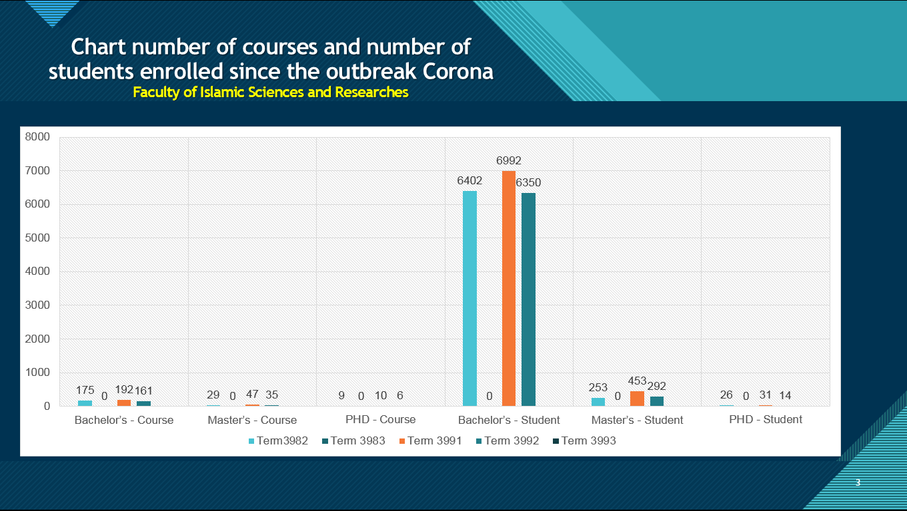
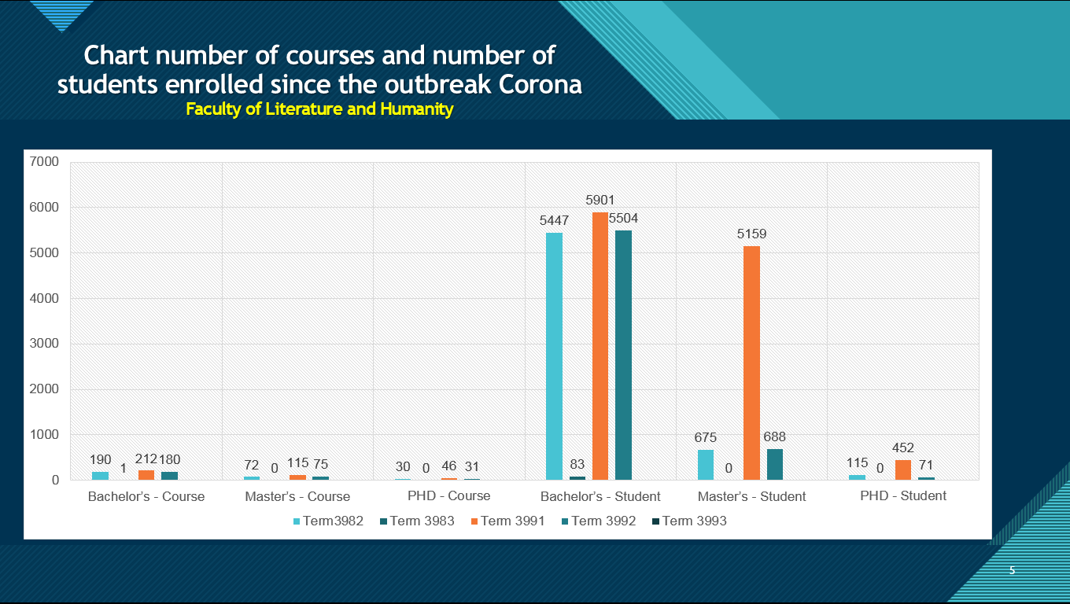
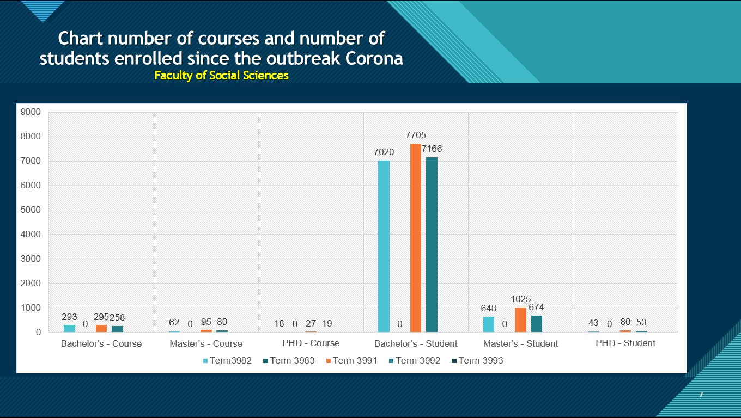
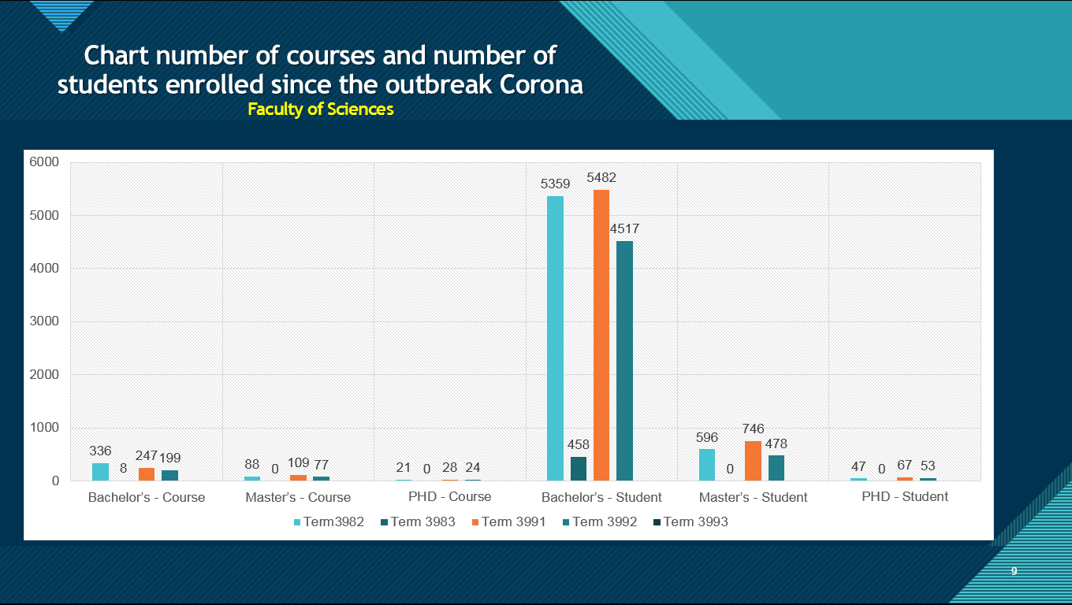
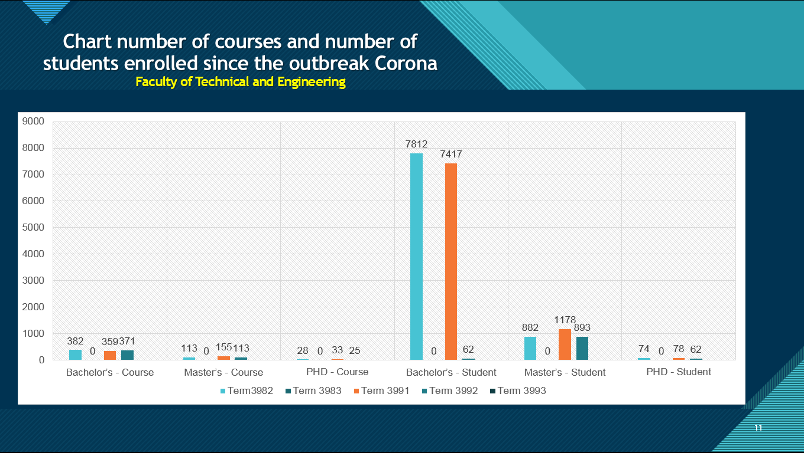
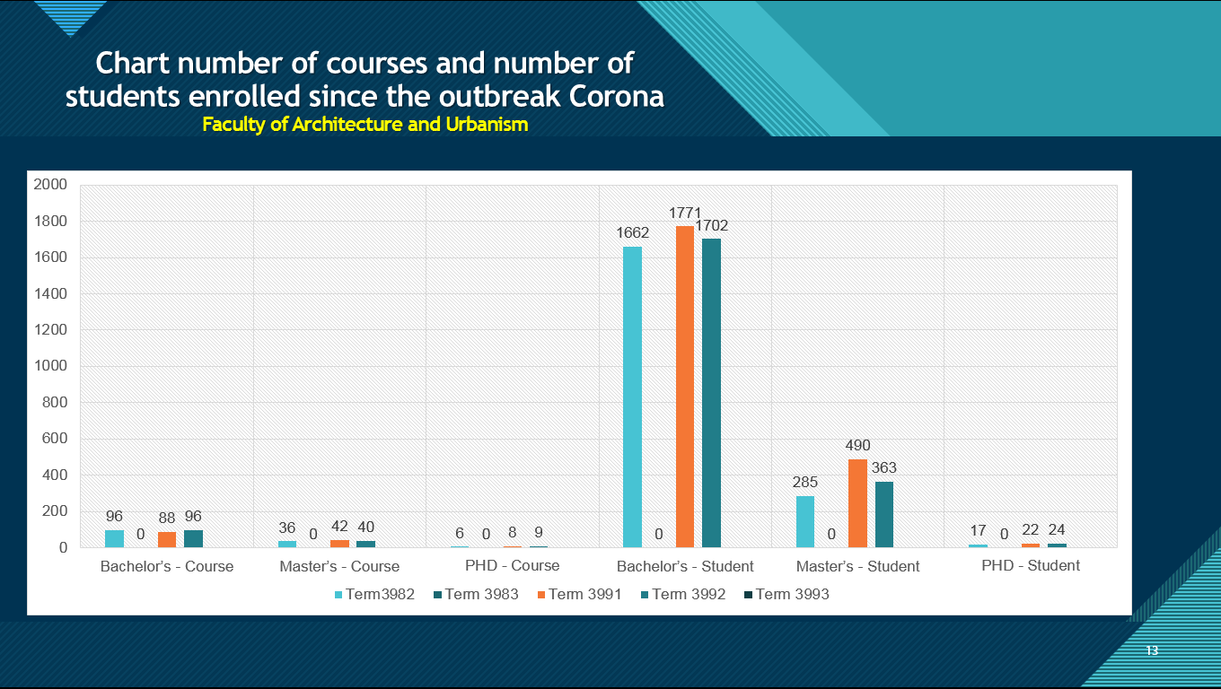
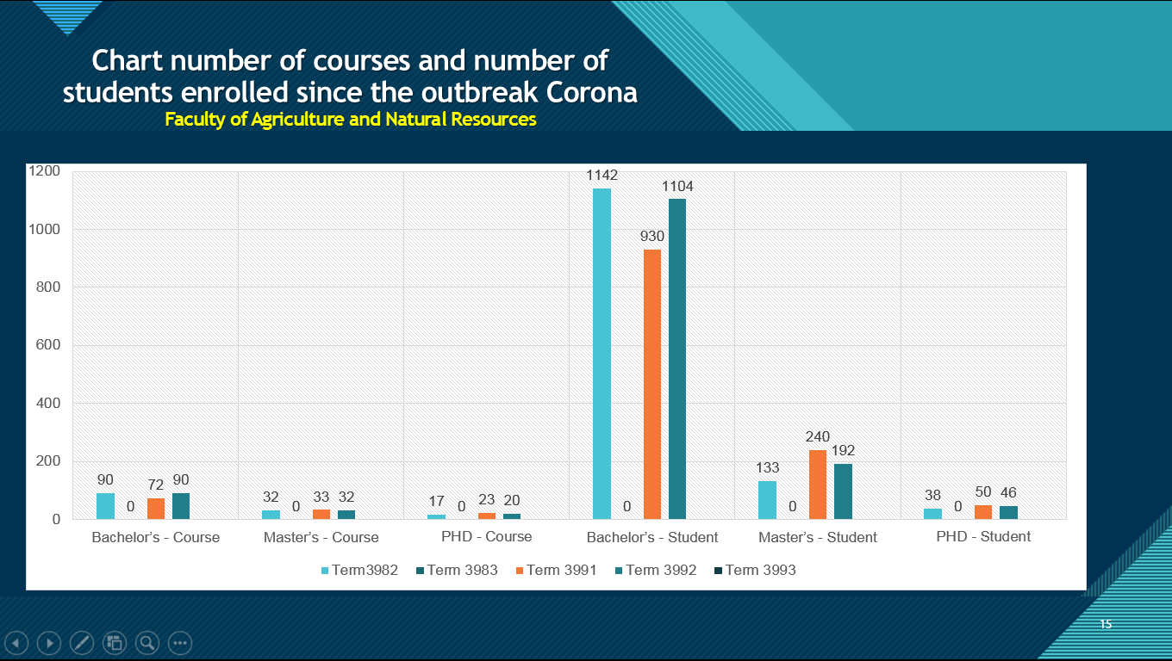
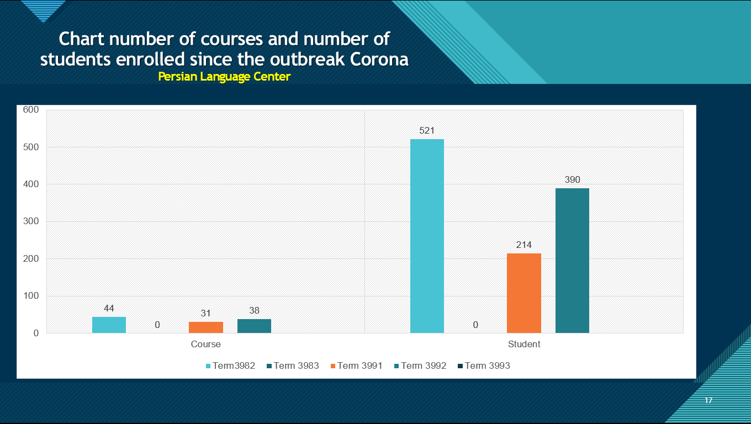
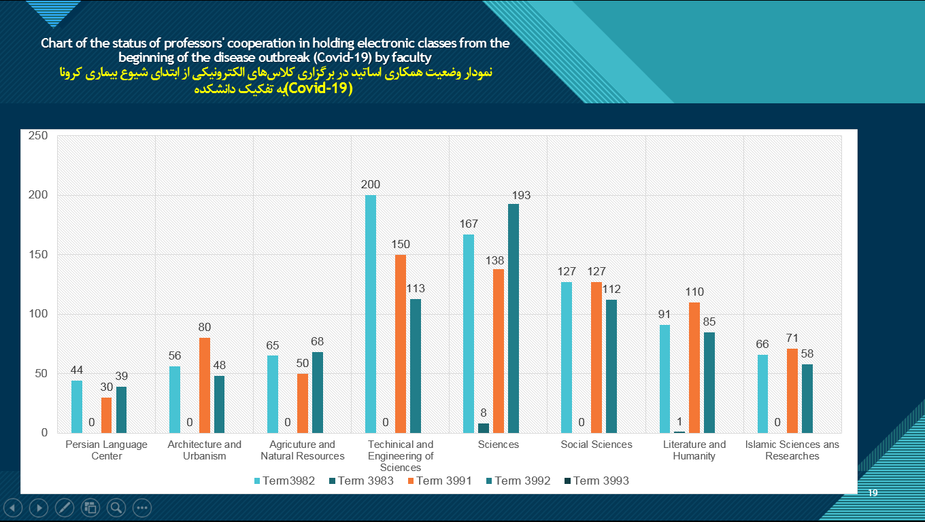

- Is TEL part of the overall strategy for your institution’s development and how?
Yes,
Apart from some disadvantages, this is a real fact that E-learning is a creative and unique method in its kind. Here are some of the advantages of e-classes.
Step One: Benefits
Reduce learning expenses for both sides, service giver and receiver of service
Make more money for companies that use e-learning
Increase productivity with e-learning
Increase job satisfaction in staff and faculty members
Optimal learning with the flexibility of e-learning courses
ELearning Always available
Comfort and relaxation in training
Flexible with the up to date knowledge
- Is there a strategy in your institution for digital innovation, TEL being a part of it? Is this strategy known within the institution at all levels?
With the outbreak of COVID-19 every university departments, had to be adapted with the new condition, in this line every departments try to use of digital technology as far as possible to achieve a better level of learning.

3.2. Technology in use
- What kind of technology are you using (e.g. platforms, videoconferencing etc.)
The platform is using at IKIU is adobe connect which is used in practical and theoretical courses, recorded videoconference also used, mostly lecturer used of PowerPoint for performing the lessons, simulations technology are also used, specially in the practical lessons.

3.3. Course development process
- How do you plan the initiation of a course (e.g. needs analysis for demand and constraint identification etc.) in TEL/online courses compared to face-to-face courses?
As it has already explained, regarding to the occurred condition, all the university courses performing online now, but the universities try to more use of technology to remove the existing shortages of virtual learning.
Some challenge that university confront with, in online learning
-One type and method of training is not suitable for all subjects
-students' Isolation
-Students' lack of motivation
-Challenge the right internet bandwidth
-Severe disruption to some Internet service providers
-Appropriate course content challenge (video, audio, file)
-The challenge of providing practical and field courses
Lack of benefits of face-to-face training in transferring the content
The challenge for professors and students in how to use e-classrooms

3.4. Stakeholders involved and their roles and tasks
- Do you involve students in TEL/online course design?
Yes, students as the receiver of educational services and as the elements of society who in touch with different community needs, in both method face to face teaching or online, being involved in the course designing, in IKIU there are evaluation forms which filled online in each term by the students in which also asking about the curriculum, students views about the curriculum (quality, hours, efficacy, needs etc.) Collected systematically at IKIU's educational and planning department and being investigate by the experts and the logical students' demand being reflected to the related scientific department to view and being respected or putting on the process of course design.
- How is the content of the course designed?
It is the same as the method already used in face to face classes which are explained
- Is there any technical support for teachers in course design? Is support given at university, faculty or department level?
At IKIU there are systematic program which work under the supervision of IKIU's educational and planning department and informing professor about how to create or modify a curriculum in this line every year some workshop or online class about curriculum designing being hold and professors being more acquainted to course designing.
The process for creating a new curriculum is clarified for the professors hence professors can propose a new course to the relevance department if the proposal for the new course was rational (mostly regarding to needs) it would be on the work plan of that department. Teachers are in touch with the new technology in their course of studies, and directly or indirectly bring it to the curriculum designing.
- Are there any facilitators that support the learners? If there are, please elaborate: describe their role, tasks and the cooperation with the lecturer.
At IKIU a systematic plan defined to support students during their studies in which For every year's students entrance in each field of study there is professor who hired and allocated to be in touch with the relevance students and advising students about the online method of teaching and in line of having a better learning environment for the students, this advisory professors transfer the students' problems to relevance University department and work to facilitate learning as far as possible, and also recommending the students about new technology and the better ways for learning.

3.5. Protocol of course assessment
- How do you evaluate the course: Is there a systematic institutional process / protocol? Are students involved at this stage?
Yes at the end of every semester there are systematic process under the supervision of deputy in educational affairs which collect results of students' view in each lesson about the professor methodology in teaching, professor nature in class, Curriculum, quality, quantity and teaching time.
- How is evaluation performed after the course is taught/delivered?
It deliver each semester online in the designed forms to the students and all the students in different field and levels of study require to fill out these evaluation forms.
- How is data collected?
The data from the students being collected on line by the educational planning department.
- Do students give feedback on teaching? If, please describe how.
The students' responds about teaching is confidential and kept in IKIU educational planning department, and student are free to give their view about different aspect of teaching in each semester.
- Who is informed about the evaluation?
IKIU educational planning department where convey the results of the evaluation to optimize the educational services and promote learning at university.
- What measures can be taken for improvement?
Students' logical view about the different aspects of Educational affairs which can progress the university being systematically transferred to the related authority and being considered and implemented as far as possible.

3.6. Identification of TEL /online quality practices or patterns of quality
- Is your Institution using Quality standards/frameworks for TEL/online?
Yes, The e-learning system constitution for the years 2021-2025 which prepared by the ministry of science and announced to the Iranian universities to be considered as an Quality standards framework for online learning method.
- If no, what are the reasons?
- Are you planning to use one in the future?
- If yes, which are they?
- What quality areas do they cover? How long have you been using them?
According to the e-learning system constitution for the years 2021-2025, the teaching-learning process consists of the following components:

-Content;
Presenting the content compiled for the purpose of e-learning for each of the curriculum courses (based on the rules and regulations approved by the Council for the Development of Higher Education), which includes the main content and supplementary resources for the learner.

-Individual and group activities
Establishing simultaneous and asynchronous online classes that enable teacher-learner interaction in relation to assigning course topics, discussing and analyzing course topics, resolving potential problems, and oral evaluation. In this regard, the use of classroom software and e-books are among the tools for the learner. Emphasizing that learners' individual and group activities are an important part of the learning-teaching process.

-Universities conducting electronic courses
All universities, both state universities and non-state universities, if they have hardware and software facilities, as well as participate in the plan of assessment, evaluation and accreditation of institutions in terms of e-learning and how to get an acceptable result after the approval of the Ministry's Higher Education Development Council and requiring the conditions.
- Does your Institution collect data in order to evaluate TEL/online programs?
Yes as it already explained.
- Is there a strategy on the use and purpose of learning analytics within the institution?
Yes, IKIU strive learning by referring to different views (scholars, researchers, professors and students) about the E-learning method, in this line IKIU's educational and planning department has the mission to pave the learning conditions in online - method.
- Does your institution consider ethical norms and government policy with respect to data protection and the privacy of students?
Yes, as far as it can be done.

3.7. Process of continuous improving of educational provision
- Are TEL/online programs reviewed, updated, and improved and how?
So far the different courses review, updated or improved the same as before (for the face to face classes) with considering and referring to the current (online learning) conditions.
- Are there any Institutional policies, structures, processes, and resources in place to guarantee the successful teaching and learning process of students with special educational needs?
IKIU as a first International state University in Iran, strive to cover all learners logical needs, in this regards by continuous refer to the learners views, has been tried to support them in all the aspects as far as possible.
- Is there an institutional policy and code of practice to ensure academic integrity and freedom and ethical behavior?
Yes, there is, as far as possible.
- Are there any electronic security measures set by your institution’s policy/code of practice?
Yes there are.

3.8. Professional development of teachers and instructional designers
- In faculty level, do people involved in designing/ developing/ evaluating TEL/online programs have specific expertise in academic and technical aspects and which?
No, they don’t have specific expertise and the process does the same as before but with considering the TEL/online regarding to the need of more use of these technology. Regarding to the current pandemic and more use of TEL/online, universities have obtained lots of experiences about optimizing the use of online technology and to progress learning, university has to consider TEL in designing /developing and evaluating the courses.
- Is the teaching staff involved in designing/ developing/ evaluating educational programs familiar with the advantages/disadvantages of using TEL/online in particular course contexts?
TEL/online is not a new phenomenon at IKIU as it was used before but after outbreak of COVID-19 this technology has been done holistically to the entire university and almost every lecturer has earned lots of experience about this method of learning.
For designing and developing the programs, regarding to the current condition, university's attempt is to coordinate course designing with the online learning system, in this line many complementary short courses about TEL and online learning are performed to the students and lecturers. The evaluation of the course quality every end of the educational term has been asked and collected from the students and professors and the results definitely impact on the course designing in university.
- Is the teaching staff trained and proficient in the use of learning technologies and (e-) assessment methods?
University in every semester has performed a courses to the teachers about online teaching, and assessment method on it, but there is a lot to be done to get the optimum results.
- Are there any particular training activities for new staff?
Performing the part time courses in term of online technology for professors and staff.
- Has the institution developed procedures to identify the support requirements of the teaching staff?
IKIU has a specific department entitled Educational and Curriculum Planning which work under the supervision of deputy of educational affairs and one of its job in this department is to collecting data from students and teachers in the end of each semester, the collected knowledge about teaching and learning environment in each term use to support learners and teachers in all the aspect as far as university capacity.
- What workshops are available for your teachers to attend? (for example: professional development, enhancement of faculty competence in skills, enhancement of faculty competence in pedagogy and enhancement of faculty competence in TEL)
All these named workshops are available at IKIU for the university staff.

Chapter 4. Industry relevance

- Name of the partner
Imam Khomeini International University- defined in UNI-TEL as P5
- Names of respondents, positions, departments
Majid Ghadiri. PhD, Head of University Startup Incubator Centre; Mohsen Davoudi.PhD, Assistant Professor at Electrical Engineering- Control; Siavash Gholizade, Assistant manager in Educational Affairs; Amir Zarkeshan .Ma, Assistant manager in international cooperation,

- Provide a short introduction describing the methodology you used and the number and types of sources
- Please keep your answer short, maximum 1-1 ½ page per question

4.1. Policy and action plan for industry-relevance
- Are industry needs considered when developing the learning model and the curricula design?
Yes industry needs are considered, especially here in this industrial province, one of the mission of university is to respond to the industry demands.
- How is industry and other stakeholders involved in the process? Are there specific needs considered for STEM education in your institution when transferring courses to technology enhanced learning or online learning? If so, please explain how.
IKIU has a specific department in it, entitled Industries Communication Department which is stablished to connect industry to the university, the manager of this department chose by the University president. This department monitoring every practical project which does by the students or professors in the industry sector and acquainted with their matters on the implementation process to be supported. Head of this department is a member of every important high council at university and so is effective member of curriculum designing at university, this is another way in IKIU to approach the university to the industries provincial needs.

4.2. Infrastructure
- Is the technical infrastructure aligned with the teaching methodology, learning activities, and e-assessment methods? If so, please explain how.
One of IKIU's attempts is to coordinate teaching methodology, learning activities, and e- assessment with the technical infrastructure and in this line university has spent lots of energy but with the new experiences earning from E- method in university, there are a lot need to be done to get to the optimum results. In this regards at IKIU every now and then views of staff, students and professors collected, discussed and being evaluated and respected for better continuation of the online method.
- Does the mentioned infrastructure and used online tools support student active learning and collaboration?
At IKIU all attempt have been done to provide the best tools to support students active learning and collaboration in the e-learning environment but there some challenges that in this kind of learning university confront with;
-One type and method of training is not suitable for all subjects
-students' Isolation
-Students' lack of motivation
-lack of students interaction
-reduction of interaction between teacher and student
-Challenge with the right internet bandwidth
-Severe disruption to some Internet service providers
-Appropriate course content challenge (video, audio, file)
-The challenge of providing practical and field courses
- The challenge to have safe examination results from the students
Lack of benefits of the face-to-face training in transferring the content
The challenge for professors and students in how to use e-classrooms

4.3. Assessment of learning
- Are (e-) assessment methods fit for purpose, allowing students to demonstrate the extent to which the intended learning outcomes have been achieved?
Yes, it has already explained
- How are they designed?
It has already explained

4.4. Functionalities of the technical infrastructure
- Does the virtual learning environment, VLE (if any) support specific pedagogical methods and tools?
It doesn't support one specific pedagogical method but regarding to experiences which achieved after the outbreak of COVID-19, the educational systems can recognize the needs for the online framework to boost the current method. The current using method of virtual learning seems to work better for the theoretical courses.
- Is the VLE based on non-proprietary web standards and is it updated to reflect technological changes? How often?
The technology which is used at IKIU to cover VLE can be updated regarding to the needs but so far it didn't update except to add some other tools to the system for more support.
- Does the technical infrastructure ensure the accessibility of the TEL/online programme by students with special educational needs and how?
IKIU's TEL/online programme designed to support students' normal need, and in some special cases it does blended( face to face and online) for example for some PhD students or some students' lab works.

4.5. Use of virtual and remote laboratories
- Does the institution provide students with an e-library?
Yes IKIU library has an e-library but with limitation and only for the books which are in English language.
- Does the institution have virtual labs?
Yes
- Does the institution have remote labs?
No

Chapter 5. TEL quality practices and support

- Name of the partner
Imam Khomeini International University- defined in UNI-TEL as P5
- Names of respondents, positions, departments
Abbas Kaviani.PhD, Deputy in Educational Affairs; Siavash Gholizade, Assistant manager in Educational Affairs. Ma; Leyla Fashalang.PhD, Instructor in curriculum Designing, Amir Zarkeshan .Ma, Assistant manager in international cooperation,
- Provide a short introduction describing the methodology you used and the number and types of sources
- Please keep your answer short, maximum 1-1 ½ page per question

5.1. Staff professionalization
- Has your institution procedures for recruiting and hiring teaching staff?
Yes there are constitution which were announced by Iran Higher Education Ministry to every Iranian State University for how recruiting and hiring teaching staff, in this rule every aspects of teacher have been considered to hire the bests in each field of study.
- Do you offer pedagogical training for teaching staff? Do you have courses specific for technology-enhanced learning? How is it organized?
Yes, in every approved curriculum, the entire credits which should be passed by relevance student are precisely defined, and each course in the curriculum is explained about the method of teaching and using references.
- How is the teaching staff coordinated during course delivery?
Upon the University academic system in which different departments and members work together and cooperate to support learning environment.
- Do you have support materials available on the intranet for online learning and teaching?
Yes there are, some of our courses have a supporting material which are available for the learners during the semester.
- Is pedagogical training mandatory for teaching staff?
Yes

Chapter 6. Opportunities and challenges for adoption of TEL practices

- Name of the partner
Imam Khomeini International University- defined in UNI-TEL as P5
- Names of respondents, positions, departments
Mohammad Raayat Jahromi.PhD, Head of IKIU Virtual Centre department; Hosein Mazaheri. Ma, expert in IKIU Virtual Centre department; Amir Zarkeshan .Ma, Assistant manager in international cooperation,
- Provide a short introduction describing the methodology you used and the number and types of sources
- Please keep your answer short, maximum 1-1 ½ page per question

- After describing the current state of art in previous chapters, identify opportunities and barriers for transformation of education. Put them in order: the most important first.

6.1. Opportunities
Reduce learning expenses for both sides in online learning, service giver and receiver of service
More benefits for companies that use e-learning
In some cases Increase productivity with e-learning
Increase job satisfaction in staff and faculty members
Optimal learning with the flexibility of e-learning courses
ELearning Always available
Comfort and relaxation in training
Flexible with the up to date knowledge
Wide area connection

6.2. Barriers
-One type and method of training is not suitable for all subjects
-students' Isolation
-Students' lack of motivation
-Reduction in students' interaction
-Reduction of interaction between teacher and student
-Teachers' challenge in controlling the online classes and monitoring all the students
-Challenge with the right internet bandwidth
-Severe disruption to some Internet service providers
-Appropriate course content challenge (video, audio, file)
-The challenge of providing practical and field courses
- The challenge to have safe examination results from the students
Lack of benefits of the face-to-face training in transferring the content
The challenge for professors and students in how to use e-classrooms

Please notice that the following chapter 7 is meant for the Iranian coordinating institution, and the EU institutions to answer.

Chapter 7. National Policies

- This chapter is obligatory only for EU partners and the Iranian coordinator.

7.1. TEL practices in Higher Education in (the name of the partner country)
- Please describe the relevant documentation on this (max 2 pages).

7.2. Approaches and Methods for Quality Assurance
- Please describe the main evaluation principles (max 2 pages).

7.3. Mission statement and strategy of the National Evaluation and Accreditation Agency
- Please describe the relevant documentation on this (max 2 pages).

7.4. Future National Policies practices, efforts, initiatives, frameworks that relate to TEL quality
- Are you aware of any plans to design new policies?
- If yes, are National-wide stakeholders involved in developing TEL criteria (policy makers, National or regional authorities, associations etc.)?

7.5. Needs for National Policies practices, efforts, initiatives, frameworks that relate to TEL quality
- Which area(s) of legislation pose a significant challenge to the application of TEL quality methods?
- What should be improved? Please provide any recommendations you may have regarding policy reforms (at all levels) that would help your organization establish TEL quality processes.
- Please provide any ideas you may have regarding reforms in educational policies (at all levels) that would help your organization establish TEL quality processes.

7.6. Training Needs for TEL Quality
- Are there any training curriculums for TEL/(online teaching practices in general?
- Which should be the top 5 educational objectives of a training curriculum in TEL/online teaching practices?
- Who should be trained for TEL/online practices?

References:

IKIU's Deputy in International Affairs.

IKIU's Deputy in educational Affairs.

IKIU's educational and Curriculum planning Department.

IKIU's Information and communication Department.
IKIU's Centre for delivering virtual affairs.

University's comprehensive strategic planning document up to 1404.

By-laws and sections of the Ministry of Science in term of preparation and curriculum designing.

IKIU's Expert and professors at different labs and faculties.

Students' view (which were collected at different levels and fields).

Professors' view (which were collected at different levels and fields).

We would like to warmly thank all the members who have contributed to this desk research!
UNITEL project team

