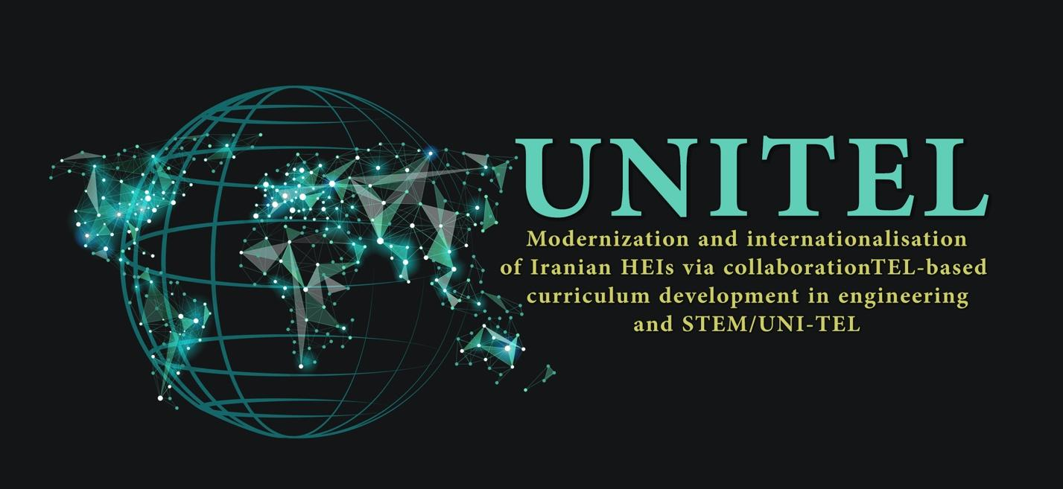

Modernization and Internationalisation of Iranian HEIs via collaborative TEL-based curriculum development in engineering and STEM

UNI-TEL Project
Industry-relevant Skills and Competencies
1.7. Roadmap on industry-relevant Skills and competences

Project | UNITEL
WP | WP1: Baseline Analysis
WP Activity | 1.1. Analysis and synthesis of data - State of the Art of HEIs in Engineering and STEM studies (Institutional level)  1.2. Analysis and synthesis of data - State of the Art of HEIs in Engineering and STEM studies (National level)  1.3. Analysis and synthesis of data - State of the Art of HEIs in Engineering and STEM studies at EU level  1.4. Addendum for Skills and competences of the Universities’ lecturers in line with the digital education era  1.5. Comparative analysis of state of the art in PC and EU for harmonization of curriculum development purposes  1.6. Preparation of Guidelines with recommendations about current practices in partner countries for curricula modernization  1.7. Roadmap on industry-relevant Skills and competences
Date | January 13, 2022
Authors and Editors | PRISMA (P4), Christos Spandonidis  Namvaran (P12), Mani Safamirzaei  Shahid Chamran University of Ahvaz (P10)  University of Turku (P2), Timo Halttunen  Guglielmo Marconi University (P1), Monica Fasciani
Dissemination Level | ☒ Institution  ☒ Local  ☒ Regional  ☒ National  ☒ International
Version | Version 12 April 2022

Table of Contents
1. Introduction 4
2. Preface: Incentives for competency-based education 5
3. Statistics; Number of Students and Academics in Iran 8
4. Similar Studies 10
4.1. Studied Competencies & Skills 11
4.2. Studied Attitudes and Personal Traits 11
4.3. Applied Methods 12
4.4. Typical Solutions 12
4.5. References 15
5. Studies by PRISMA 16
5.1. Technical Skills 17
5.2. Soft Skills 18
6. Studies by Namvaran P&T 18
6.1. Results of Survey 19
6.2. Priority Detection 20
6.3. Training of Employed University Graduates 21
6.4. Evaluation of Universities 21
7. Studies by Sharif University of Technology 23
7.1. Collaboration of Companies with Universities 23
7.2. Skills 25
7.3. Soft Abilities 26
7.4. Companies Viewpoints 26
8. Conclusion 28
References 29
Resources 30

Introduction
UNI-TEL project is a joint project founded by Erasmus+ programme of European Union and carried out for modernization and internationalization of Iranian higher education institutes. Partners of this project are listed in below table:

Partner No. | Institute / Company | Country
01 | Università degli Studi Guglielmo Marconi | Italy
02 | TURUN YLIOPISTO | Finland
03 | UNIVERSIDADE ABERTA | Portugal
04 | Prisma Electronics ABEE | Greece
05 | IMAM KHOMEINI INTERNATIONAL UNIVERSITY | Iran
06 | UNIVERSITY OF SISTAN AND BALUCHESTAN | Iran
07 | SHIRAZ UNIVERSITY | Iran
08 | University of Isfahan | Iran
09 | UNIVERSITY OF TEHRAN | Iran
10 | SHAHID CHAMRAN UNIVERSITY OF AHVAZ | Iran
11 | Sharif University of Technology | Iran
12 | Namvaran P&T | Iran

Based on specified goals in the UNI-TEL project, different work packages have been defined and task 1.7 within WP1 has been considered to identify required skills and competencies in the industry. In this regard, the following activities have been carried out:
- PRISMA (Partner#4) has performed a study and provided obtained results.
- Namvaran P&T (Partner#12) has performed an internal survey and provided obtained results.
- Sharif University of Technology (Partner#11), as part of additional activities foreseen within WP1, has prepared a questionnaire (which has been reviewed and commented by other partners and distributed among companies) and provided obtained results.

Preface: Incentives for competency-based education

The UNI-Tel project aim to advance acquisition of industry-relevant skills and competences is connected to a larger discourse in educational policy, motivated by the need to reduce the gap between education and the world of work.

In terms of policy development in the European context, the single most important effort for competency-based education has been the Tuning project and it’s extensions from Europe to other countries and regions in the world. The Tuning project, or Tuning Educational Structures in Europe, was carried out between 2000 and 2005 in the European Union member states to facilitate implementation of the Bologna Process objectives for creating an European area of Higher Education. Tuning focused on introducing the competency-based approach to curricula. However, as Lamboley (2017) remarks, tuning the educational process was not only seen in the sense of tuning teaching and learning on a single course level, but to a large extent promote compatibility, comparability and competitiveness in the educational system. Therefore, the tuning philosophy extended from the request of writing course descriptions in the language of learning outcomes to stressing the role of the learner, enhancing student mobility, and relevance of employability to the educational process. In short, opening the educational process to discuss the needs of the learners and the employers.
However, competence is not a clearly defined concept in educational literature (Želvys & Akzholova, 2016). In the European Union educational policies, and in the Tuning project in particular, “Competences represent a dynamic combination of cognitive and metacognitive skills, demonstration of knowledge and understanding, interpersonal, intellectual and practical skills, and ethical values” (Gonzalez, Wagenaar (eds.), 2008). The concept of competences has become to refer both to pre-professional and more generic, transferable competences.
Due to broadening of the Bologna Process to countries beyond Europe, the use of the competence-approach has been reflected in various cultural and social contexts. Želvys & Akzholova (2016) point out in their study that in contexts where centrally governed higher education system are in place, learning outcomes and competences may be understood as synonymous. Stemming from their analysis of a project development with Central Asian countries, researchers observed that educators stressed the need of the educational process to meet a nationally governed, definite set of standards. To contrast this view, they pinpointed that competences are qualities developed by the learner, whereas learning outcomes are determined by academic staff, and implemented in the framework of various courses and the curricula (Želvys & Akzholova, 218, 2016).
In the field of engineering, the Tuning approach has been tested e.g. in Russia (see Lunev et. al., 2013). In comparison to the European and American educational systems, the approach resulted into good level of concordance of the national engineering education towards the international benchmarks. In Russia, as in other countries and regions, competence development has been assessed in the dimensions of importance and achievement of a set of competences. Importance and achievement has been evaluated by teachers, students and employers. Hence, these assessments describe the level of agreement of necessary competences for the industry, and how the employers see the students are able to achieve those competences. For example, in the Russian context, research detected greater gaps in student performance in the areas of ability to plan and manage time, ability to evaluate and maintain the quality of work produced, and ability to focus on quality. (Lunev et. al., 2013.)
Working-life relevance is not the only concern of competence development in education. Sackey et. al. (2014) bring to attention that competence development in engineering education has wider perspectives than those of students, teachers and employers, namely the society at large. In their analysis of the Tuning approach in engineering education in Africa, greatest gap between importance and achievement of mechanical engineering students’ competences was detected in entrepreneurial talent and self-confidence. Contextual analysis across mechanical engineering companies detected employer preference for importing, not developing, technology in Africa. While all stakeholders agreed on importance of the mechanical engineering competences related to applying knowledge to conceive, design, analyze and manufacture products and systems, they ranked levels of achievement lower to levels of importance. Interestingly, research pointed out that risk management, efficient use of natural resources, life cycle assessment and working in multi-diciplinary teams were amongst the largest gaps between levels of importance and achievement. In the African context, researchers argued that low ranking of competences in safety, risk management, quality control and life cycle assessment mirrored the low level of technological development in the continent.
Furthermore, competence development may also be assessed beyond the level of application. In the context of architecture and design in the Tuning-MEDA project, Hakky (2016) investigated student achievement to analyze, synthesize and evaluate. The researcher brought to attention the often faced challenge in the teaching culture amongst higher education institutions in Syria and the MEDA countries (Middle East, North Africa), where teacher and learner focus is on memorization, with the purpose of preparing student for examination and getting grades passed. Interestingly, this study brought to the front not only the mentioned levels of students’ achieved competences (knowledge, comprehension, application and beyond) but also the importance of participation to a community of future practitioners, the positive effects of collaborative learning, and efforts in building a relevant body of knowledge and understanding of the level of mastery that is relevant for the industry.
Research reviewed in Europe, Russia, the Middle East and Africa shows that regional, national or even wider cultural and societal circumstances have an impact on how the concept of competences are perceived. Hence, it is crucial to explore the experiences of different stakeholders – teachers, students and employers – in order to understand what competences are needed and in which level and under which circumstances they can be developed to the optimal level.

Statistics; Number of Students and Academics in Iran
The official published bulletin by the Institute for Research and Planning in Higher Educations (IRPHE) affiliated to the Ministry of Science, Research and Technology of Iran (MSRT) shows that at the end of Iranian year of 1399 (March 2021), total number of students at universities and other higher education institutes is approximately 3.2 million. The graph below shows the distribution of students in different fields of study:

Iranian higher education institutes have more than 87,000 full time faculty members, who are active in different fields of study and research, as shown in below picture.

All aforementioned data are available online at:
https://irphe.ac.ir/index.php?sid=25&slc_lang=fa&slct_pg_id=769

Similar Studies
Several studies about competencies and required skills at labor market have been carried out by others and have briefly reviewed in this section. Competencies and skills required for engineers and other experts in the labor market are changing due to many reasons and continuous tracking of needs and skills is prominent. STEM experts are required to have strong technical/scientific skills and good intrapersonal, social, intercultural, and sustainability competencies. As already mentioned in the Preface, several projects have investigated skills and competencies that are more useful to engineers and scientists in different labor markets. Some examples are:
- Global People, Measuring and Comparing Achievements of Learning Outcomes in Higher Education in Europe (CALOHEE)
- Time to Assess Learning Outcomes in E-Learning (TALOE)
- Program for International Student Assessment (PISA)
- Tools for Enhancing and Assessing the Value of International Experience for Engineers (TAVIE)
- Etc.

What distinguishes STEM experts from other disciplines is that there is almost a common understanding throughout the world of what STEM experts (e.g., an engineer) are supposed to know and be able to do. Unifying such understanding needs international formalization; however, special attention shall be given to local market demands, economic condition, and local cultures.

Studied Competencies & Skills
Below competencies and skills that have been considered in previous studies, based on defined goals in each project, to recognize current and future needs.
- Communication in local language
- Communication in foreign languages
- Decision making
- System thinking
- Teamwork
- Negotiation
- Conflict management
- Problem solving
- Encouraging others
- Motivating others
- Cooperation within a team
- Holistic thinking
- Long term vision
- Ethical orientation
- Etc.

Studied Attitudes and Personal Traits
Following attitudes have been surveyed in previous studies and projects:
- Empathy and sympathy
- Openness to new experiences
- Openness to changes
- Acceptance of differences
- Flexibility and resilience
- Adaptability
- Curiosity
- Sociability
- Self-awareness
- Initiative
- Creativity
- Stability and perseverance
- Relation building
- Etc.

Applied Methods
In different projects, questionnaires have been prepared and distributed among target institutes and companies, and experienced personnel from companies and universities have been interviewed. Results of surveys reveal the weak points and what is missing.

Typical Solutions
Based on goals of studies, different solutions have been proposed in finalized projects. Although a proposed solution may be applicable to a specific study (depending on targeted society), it can be a guideline for UNI-TEL project while proposing solutions and road map.
Some of the interesting solutions, which may also be applicable to UNI-TEL are reviewed in this section.

- Training & Continual Professional Development (CPD)
It is necessary for stakeholders (society, companies, engineering professional bodies, employers, and engineering schools) to have engineers with competences, knowledge, skills, and attitudes that foster trust in engineering activities and ensure the proper qualification of engineers. It is prominent to guarantee that STEM experts competences and skills are consistent with requirements. In addition to good training, their knowledge shall be updated continuously to make them ready to face new challenges. While basic engineering knowledge and principles stay the same, some parts of the engineering knowledge acquired at school/university is outdated after only a few years.
Some European countries, such as Denmark, Finland, France, Germany, Ireland, Sweden, and United Kingdom, in addition to commitment for good training, have traditionally invested in the CPD of engineers. The Federation of European National Engineering Organizations (FEANI – www.feani.org) adopted a system of measuring CPD in terms of credits and a process to record those achievements. In addition to a standard set of competences, many professional engineering organizations and regulation bodies mandate ongoing training and competence development to maintaining standards for mostly the safety of citizens.

- To recognize and register CPD achievements
A system to measure and quantify the periodic CPD can be adopted allowing comparison of engineers’ qualifications. Periodic CPD shall be mandatory for all engineers given the social responsibility of the activities and the legal and economic consequences of underperformance.

- To establish a unique framework for STEM professionals
While it is crucial to educate specialists, it is even more important to have a greater focus on the basic STEM and engineering programs. A foundation for a framework is needed in a society.

- To educate the educators
There should be opportunities for educators at all levels to acquire competences in teaching based on new requirements. New demands amplify the necessity to better understand education system change and adopt with new requirements.

- To focus on skills and competences via national policies
The national policies must encompass the development of education and competences, as well as upskilling and reskilling within the lifelong learning framework.

- To conduct more research on the demand for skills
Researching which skills and competences are needed in the future can help preventing skills mismatch and provide a clear picture of the demands. For instance, if the national policy is based on green technology and circular economy, relevant skills shall be recognized and receive significant attention and budget.
- To provide funding for higher education institutions to enable the transition to the new requirements
The transition into new requirements is dependent on a mindset change. Funding should be made available to enable existing academic staff to acquire competences. Public funding for higher education institutions’ research, development and innovation activities could be focused on new requirements.

- To create spaces for upskilling
Due to the formal constraints that higher education institutions operate within, they may not change education and re-education quickly enough. By creating spaces for upskilling, employers (companies and universities) could increase shared understanding of current constraints and new principles and requirements.

- To train graduate engineers and STEM professionals
It is necessary to build new and expand existing collaborations between the private sector, companies, STEM professionals, and universities. Established programs should be further supported to offer flexible re-education through more short courses and study modules explicitly developed for lifelong learning opportunities.

- Promote STEM professionals as leaders
There is a need to step up the awareness-raising of the opportunities for young people to make an impact towards a more sustainable future through STEM professions. This could increase the attraction of the engineering and STEM professions.

- To modify STEM programs
Education system must reflect the change that is taking place on all levels of life. Digitalization, internationalization, and the need for interdisciplinary approaches demand different skills and mindsets. Higher education institutions (in cooperation with employers, companies, and engineering associations) must react and adopt their STEM programs to include major trends.

References
Below references have been used for preparation of this section:
- Isabel Ortiz-Marcos, Valeria Breuker, Rocío Rodríguez-Rivero, Björn Kjellgren, Frédéric Dorel, Marco Toffolon, Diego Uribe and Virna Eccli, “A Framework of Global Competence for Engineers: The Need for a Sustainable World”, Sustainability 2020, 12, 9568; doi:10.3390/su12229568
- Thomas Kiefer, “THE UN SUSTAINABLE DEVELOPMENT GOALS; A summary of FEANI’s approach, September 2021, available online at www.faeni.org
- A. Soeiro, K. Sunderland, “How to promote, based on education and training, from a lifelong learning perspective, the skills needed for Europe to establish a more just, more cohesive, more sustainable, more digital and more resilient society”, European Economic and Social Committee Opinion piece, January 2020.
- Sine Beuse Fauerby, Jussi-Pekka Teini, Robert Nyheim-Jomisko, Kristoffer Boesen, Ludvig Vraadal, “TOWARDS A CIRCULAR ECONOMY; Skills and competences for STEM professionals”, Association of Nordic Engineers, Nov. 2021.

Studies by PRISMA
PRISMA (Partner#4), a European company in the field of electronics and based in Greece, has performed some studies, and provided obtained results. To make the evaluation quantitative, PRISMA has defined below levels for each skill.
Level | Explanation
1 | lack
2 | merely present
3 | present
4 | confidence
5 | expert

Difference of target level and today level shows criticality of each skill. If criticality is 3 or higher for a skill, that skill shall receive more attentions. Below formula shows how criticality is calculated:
$Criticality=Target Level-Today Level$

Technical Skills
PRISMA has provided below table for required technical skills and evaluated available level, target level and criticality for each skill.

 | Technical skills | Skills breakdown | Level today | Level targeted | Criticality
1 | Embedded SW | Serial Protocol identification | 1 | 4 | 3
 |  | Digital sensor manipulation | 3 | 4 | 1
 |  | Analog sensor manipulation | 2 | 4 | 2
 |  | Time synchronization | 1 | 4 | 3
2 | Software | Cloud computing | 3 | 4 | 1
 |  | API development | 3 | 4 | 1
 |  | Services development | 2 | 4 | 2
 |  | Dockerised architecture | 1 | 4 | 3
 |  | Real time data manipulation | 2 | 4 | 2
3 | Hardware | Sensor identification | 2 | 4 | 2
 |  | High frequency data manipulation | 1 | 4 | 3
 |  | Filter design | 3 | 4 | 1
4 | Data analysis | Descriptive data analysis | 3 | 4 | 1
 |  | Inferential data analysis | 2 | 4 | 2
 |  | Benchmarking | 2 | 4 | 2
 |  | System comparisons | 1 | 4 | 3
5 | Responsible AI | Data preparation | 2 | 4 | 2
 |  | Validation of outcome | 1 | 4 | 3
 |  | Data use | 1 | 4 | 3
 |  | Method selection | 3 | 4 | 1
 |  | Responsibility issues | 1 | 4 | 3

Soft Skills
PRISMA has provided below table for required soft skills and evaluated available level, target level and criticality for each skill.
 | Soft skills | Skills breakdown | Level today | Level targeted | Criticality
1 | Remote working ability | ICST knowledge | 3 | 4 | 1
 |  | Asynchronous working status | 1 | 4 | 3
 |  | Unsupervised working status | 1 | 4 | 3
 |  | Resilience and self-discipline | 2 | 4 | 2
 |  | Social communication online | 2 | 4 | 2
2 | Collaboration | Team working | 2 | 4 | 2
 |  | Cross-functional operation | 2 | 4 | 2
 |  | Presentation Skills | 2 | 4 | 2
 |  | Feedback acceptance/provision | 1 | 4 | 3
3 | Multi-tasking ability | Multi-tasking design | 2 | 4 | 2
 |  | Inductive/Deductive Reasoning | 2 | 4 | 2
 |  | Prioritization | 2 | 4 | 2
 |  | Deliverable submission on time | 2 | 4 | 2
 |  | In time reporting of status | 1 | 4 | 3
4 | State of the art review | Review of technology | 3 | 4 | 1
 |  | Review of academic works | 2 | 4 | 2
 |  | Critical assessment of solutions | 1 | 4 | 3
5 | Sustainability in design | Experimentation | 2 | 4 | 2
 |  | Commercial Awareness | 2 | 4 | 2
 |  | Independent Thinking | 1 | 4 | 3
 |  | Lifecycle management | 1 | 4 | 3
 |  | Environmental Awareness | 2 | 4 | 2
6 | Working environment | Communication | 3 | 4 | 1
 |  | language skills | 3 | 4 | 1
 |  | Adaptability | 3 | 4 | 1
 |  | Multiple perspectives | 2 | 4 | 2

Studies by Namvaran P&T
Namvaran P&T (NPT), an Iranian company in the field of gas, oil and petrochemical industries based in Tehran (Partner#12), has performed an internal survey and details of study have been provided in report P238-GRP-0001. In this study, 19 experienced NPT’s personnel have participated and they have been asked to provide their viewpoint regarding importance of each required skill/parameter for employment at NPT and evaluation of university graduates and employed fresh engineers based on these skills / parameters.

Results of Survey
Results have been summarized in below table:

Skill / Parameter | Importance | Skill
Working with Computer and General Software | 84.74 | 55.26
Familiarity with Professional Engineering Software | 71.05 | 45.79
Proficiency in English (or other Foreign Languages) | 74.21 | 52.11
Familiarity with Engineering Documents and Drawings | 64.74 | 27.89
Familiarity with Engineering Standards and Procedures | 66.84 | 26.84
Team Work Skills | 81.58 | 44.74
Social Behavior | 80.53 | 52.11
Problem Solving Skills | 75.26 | 45.79
Personal Time Management Skills | 75.26 | 43.68
Management and Leadership Skills | 61.58 | 38.42

In the above table, importance of skill and available skill level have been quantified between 0 and 100 (based on received replies from NPT’s senior personnel) to show lowest and highest importance / level. Above table reveals that NPT is generally evaluating university graduates for employment based on below check list:
- Working with Computer and General Software
- Team Work Skills
- Social Behavior
- Personal Time Management Skills
- Problem Solving Skills
- Proficiency in English
- Familiarity with Professional Engineering Software
- Familiarity with Engineering Standards and Procedures
- Familiarity with Engineering Documents and Drawings
10- Management and Leadership Skills

Priority Detection
A priority index has been defined as presented below, to identify which skill requires more attentions and investment based on importance and available skills within university graduates.

$Priority Index=Importance Number ×(100-Available Skill Number)$

Skill / Parameter | Priority Index | Priority
Working with Computer and General Software | 3,790.86 | 9
Familiarity with Professional Engineering Software | 3,851.80 | 7
Proficiency in English (or other Foreign Languages) | 3,554.29 | 10
Familiarity with Engineering Documents and Drawings | 4,667.87 | 2
Familiarity with Engineering Standards and Procedures | 4,890.03 | 1
Team Work Skills | 4,508.31 | 3
Social Behavior | 3,856.79 | 6
Problem Solving Skills | 4,080.06 | 5
Personal Time Management Skills | 4,238.50 | 4
Management and Leadership Skills | 3,791.97 | 8

Training of Employed University Graduates
Based on received replies from experienced personnel of NPT, employed university graduates are not completely qualified as fresh engineers and considerable time (and cost) shall be spent by NPT to train them. Below graph shows average time spent at NPT to train university graduates to reach fresh engineer level.

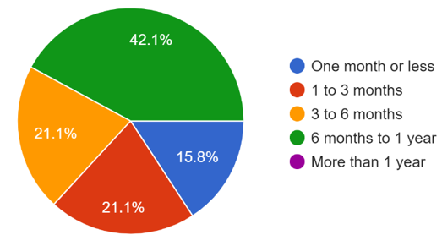

Evaluation of Universities
NPT’s senior staff have been asked to evaluate universities (taught subjects, professors, and facilities). Results have been summarized hereunder:
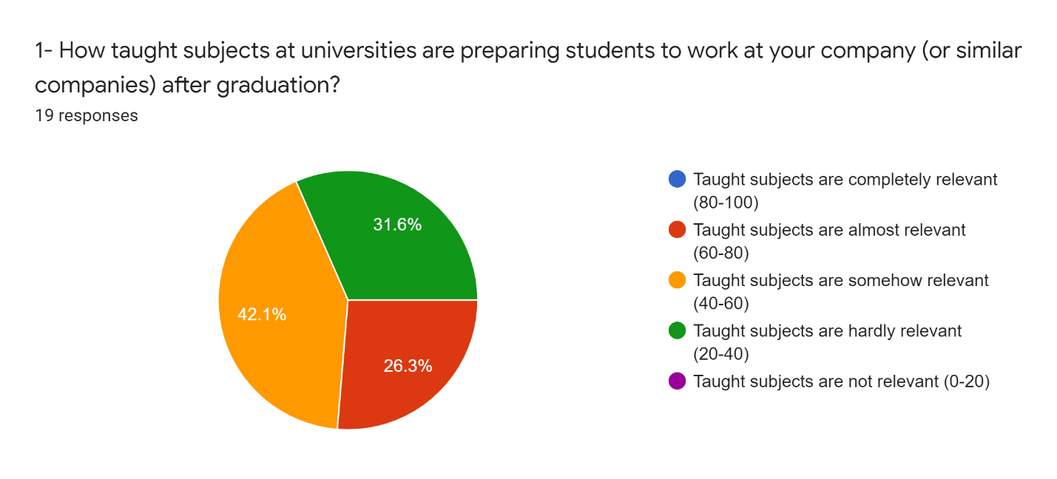

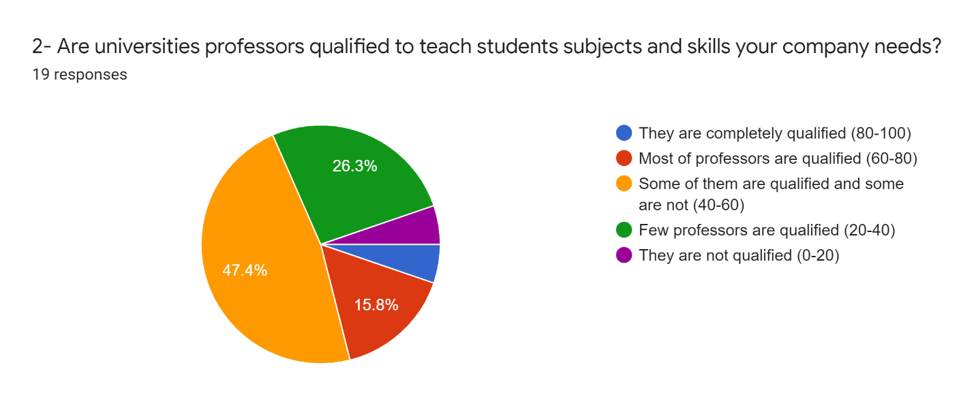

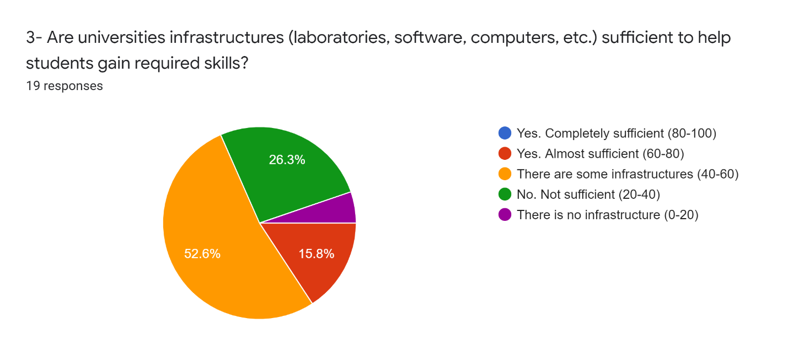

Studies by Sharif University of Technology
Note: This section shall be updated based on new results of survey. To be confirmed by SUT.
Sharif University of Technology (SUT), an Iranian technical university based in Tehran (Partner#11), has prepared, together with Turku University and Marconi University, within the framework of WP1 of the UNITEL project, a questionnaire to ask different companies about their viewpoint toward required skills in market. This questionnaire has been reviewed by other partners and commented, prior distribution. Totally, 21 responses have been received.

Collaboration of Companies with Universities
Participants have been asked answering to specific questions about collaboration with universities. Responses are summarized hereunder. Unfortunately, there are limited collaboration between companies and universities and this deficiency may show why universities are not aware of industry requirements.

Skills
Participants have been asked about skills which require more attentions and training. Below graph represents summary of obtained results.

Obtained results show that technical, experimental, laboratory and project management skills should be developed and improved among university students. Other skills may be considered at lower priorities.

Soft Abilities
Participants have been asked about soft abilities. Below graph shows summary of received replies and indicates universities should work more on teamwork skills, responsibility and accountability, professional ethics, perseverance and flexibility, creativity, and critical thinking.

Companies Viewpoints
Participants have been asked to provide their view point regarding below questions/facts.
Code | Fact / Question
h | Senior engineers and company executives know the basics of STEM information.
i | Student knows STEM basic steps.
k | Universities collaborate with you to teach some technical skills to the students.
AA | University has a process for handling research and development projects coming from the industry sector.
AF | In my opinion there is a gap between students' disciplinary knowledge and application to theory.
AG | We need to train our newly hired engineers in practical action after graduation.
AH | While academic staff may work closely with industry on research, there is less motivation to engage with industry in relation to education.
AI | Academics have the needed networking and entrepreneurial mindset to develop high-impact industrial engagement initiatives.
AJ | Engineering graduates do not have the engineering related skills needed for a workplace like problem-solving.
AK | Engineering graduates who have experience with TEL work better in teams and have better communication and collaboration skills.
AL | We are satisfied with the work of students who come to the company for their engineering internship
BJ | In our company there would be opportunities to learn important engineering skills that were not acquired at the university

Below graph represents received answers. Based on these results, university graduates are not qualified and well trained and companies must spend significant time and budget for training fresh engineers. All participants believe that there is gape between university courses and industry requirements.

Conclusion
Performed surveys in Iranian market and within Iranian companies are indicating that higher education system in engineering and science sectors, requires significant modifications and improvements. There are considerable deficiencies and companies believe that there is significant gap between what they need and what is taught to students.
In addition to deficiencies related to technical issues, which has been mentioned by companies, there are other skills that should receive more attentions. Skills related to teamwork, problem solving, responsibility, accountability, flexibility, etc. (addressed in previous sections) are extremely needed by companies but they are not developed by universities.
Limited collaborations and contacts between companies and universities indicate that companies and universities are not aware of weaknesses, requirements and strengths of other side and they are working almost separately.

References
Gonzalez, J., Wagenaar, R. (eds.). (2008). Universities’ contribution to the Bologna process. An introduction. Bilbao: Publicaciones de la Universidad de Deusto.
Hakky, R. (2016). Improving Basic Design Courses through Competences of Tuning MEDA. Tuning Journal for Higher Education, 4(1), 21–42.
Lamboley, J.-L. (2017). Tuning History: The French Experience. Arts and Humanities in Higher Education: An International Journal of Theory, Research and Practice, 16(4), 371–384.
Lunev, A., Petrova, I., & Zaripova, V. (2013). Competency-Based Models of Learning for Engineers: A Comparison. European Journal of Engineering Education, 38(5), 543–555.
Sackey, S. M., Ancha, V. R., Chinyama, M. P. M., Onana, C. A., Danwe, R., Megahed, M. M., Delpouve, B., Chama, S., Mahomed, N., Kayibanda, V., Mukeba Yakasham, L. K., & Müller, A. (2014). Collaborative Meta-Profile Development to Harmonise Mechanical Engineering Education in Africa. Tuning Journal for Higher Education, 2(1), 161–178.
Želvys, R., & Akzholova, A. (2016). Problems of Introducing a Competence-based Learning within the Context of Bologna Process. Pedagogy Studies / Pedagogika, 121(1), 187–197. https://doi.org/10.15823/p.2016.13

Resources
Global People, Measuring and Comparing Achievements of Learning Outcomes in Higher Education in Europe (CALOHEE), https://www.calohee.eu/

Time to Assess Learning Outcomes in E-Learning (TALOE), https://taloe.up.pt/

Program for International Student Assessment (PISA), https://www.oecd.org/pisa/

Tools for Enhancing and Assessing the Value of International Experience for Engineers (TAVIE), https://blogs.upm.es/tavie/whats-ta-vie/

