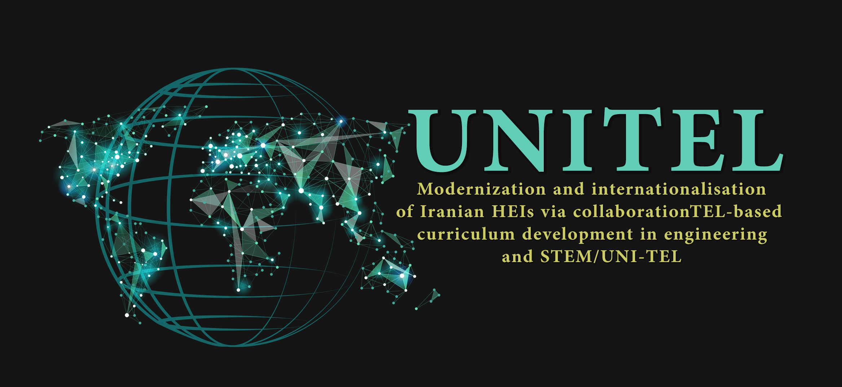

Modernization and Internationalisation of Iranian HEIs via collaborative TEL-based curriculum development in engineering and STEM

Project № 617496-EPP-1-2020-1-IT-EPPKA2-CBHE-JP

Deliverable NO. TITLE

DELIVERABLE DESCRIPTION
Deliverable number and name
Due date
Work Package
Author
Reviewers
Approved by
Dissemination level
Version

Document history
Issue date | Version | Comments

Disclaimer
This document contains the description of the UNITEL project work and products. Certain parts of it might be under partners’ Intellectual Property Right (IPR) rules therefore, prior to its use please contact the consortium leader for approval.
In case you believe that this document harms in any way IPR held by you as a person or as a representative of an entity, please do notify us immediately.
The authors of this document have taken any available measure in order for its content to be accurate, consistent and lawful. However, neither the project consortium as a whole nor the individual partners that implicitly or explicitly participated in the creation and publication of this document hold any sort of responsibility that might occur as a result of using its content.

Table of Contents
1. Introduction 6
1.1. TITLE 6
1.2. TITLE 6
2. TITLE 6
2.1. TITLE 6
3. List of Annexes 7

List of figures
Figure 1. TITLE 7
Figure 2. TITLE 7

List of tables
Table 1. TITLE 7

Acronyms
GA – Grant Agreement
PA – Partnership Agreement
EC – European Commission
KoM – Kick-off Meeting
PM – Project Manager
SC – Steering Committee
WT – Work Team
WP – Work Package
WPL – Work Package Leader
QA – Quality Assurance
TEL – Technology Enhanced Learning
HEI – Higher Education Institution
EU – European Union
IR – Islamic Republic of Iran

Abstract

Introduction

Figure 1. TITLE

TITLE

Table 1. TITLE

TITLE

Figure 2. TITLE

TITLE

TITLE

List of Annexes

Annex I -
Annex II -

